# **Maximum Likelihood estimation**

GOAL 🡪 How to learn the parameters for Logistic Regression model ???

## **Goal: Learning parameters of logistic regression**

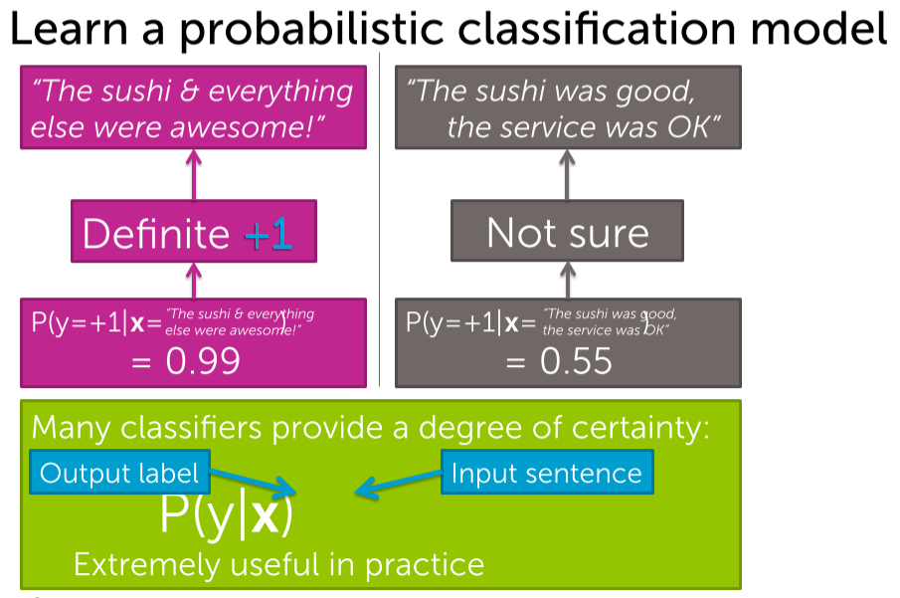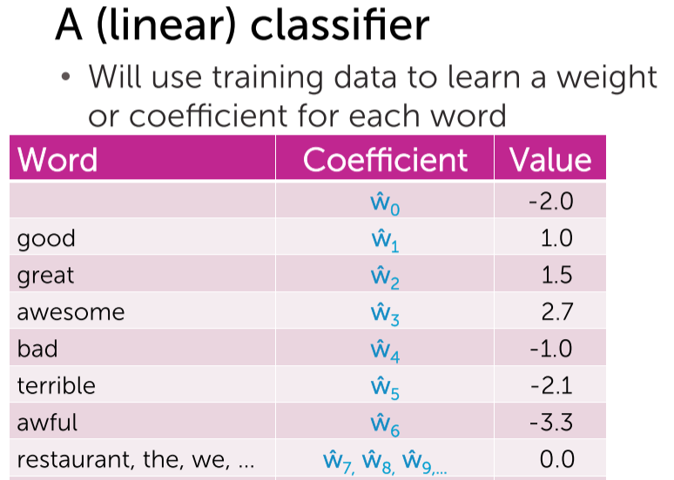

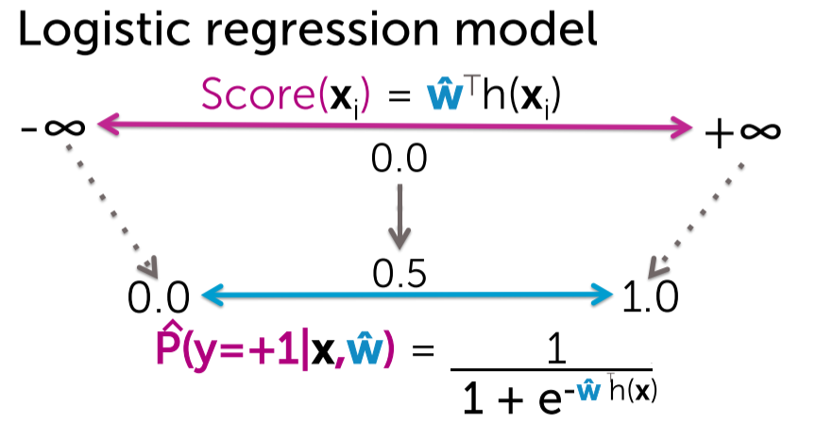

## **Intuition behind maximum likelihood estimation**

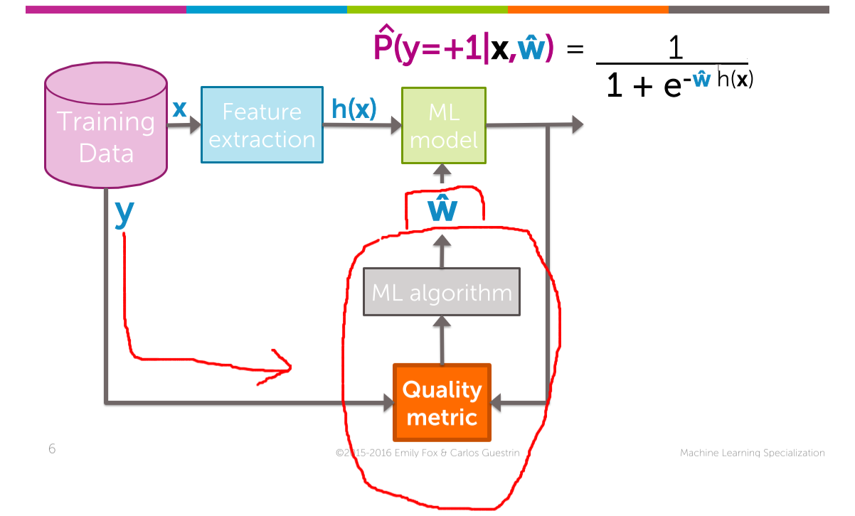  
Our aim: To get the highest probability, but getting the highest probability depends upon the coefficient. Quality metric comes into the picture.



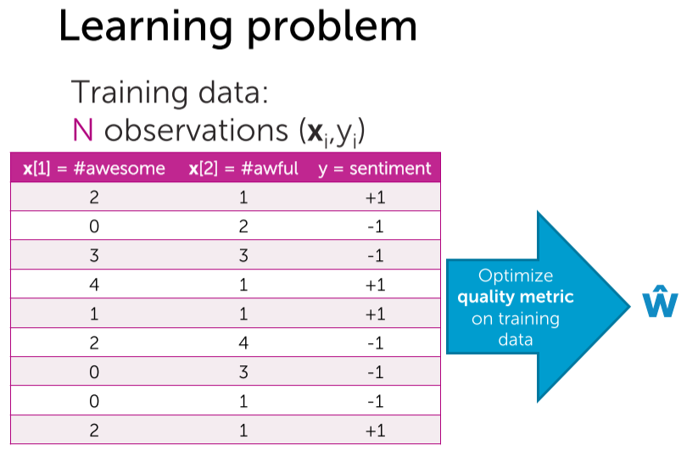

Lets see how the quality metric look like???

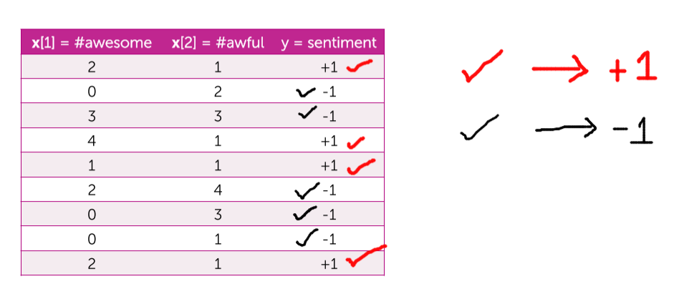



Negative Sentiments Positive Sentiments

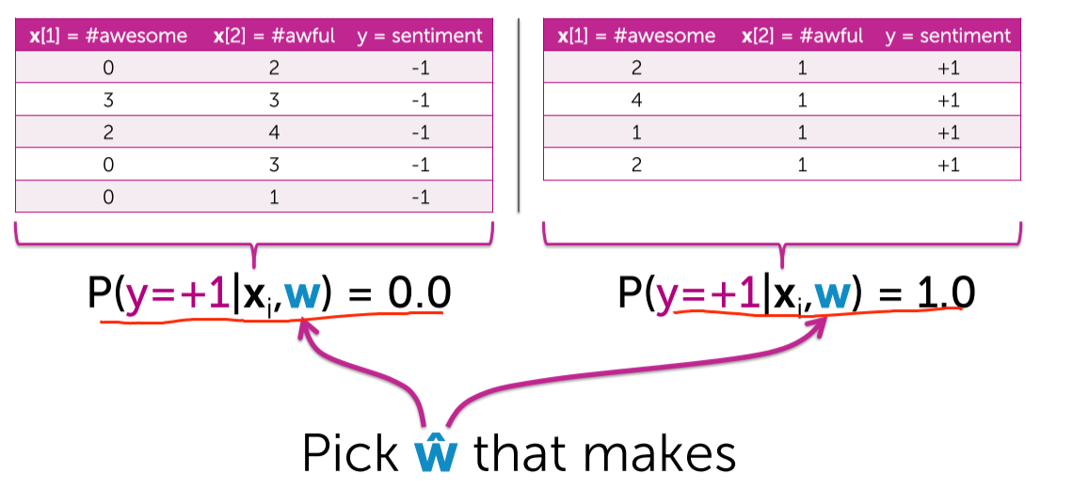

* We cannot able to find the w^ that achieves 0 for -ve and 1 for +ve.
* So the quality metric/likelihood function tries to figure out a kind of on average it measures the quality throughout all the data points.
* With the likelihood function, I can evaluate multiple lines or multiple classifiers.

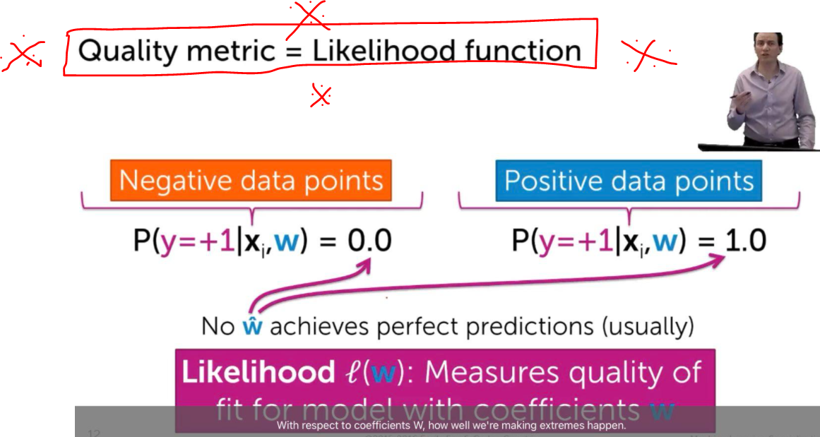

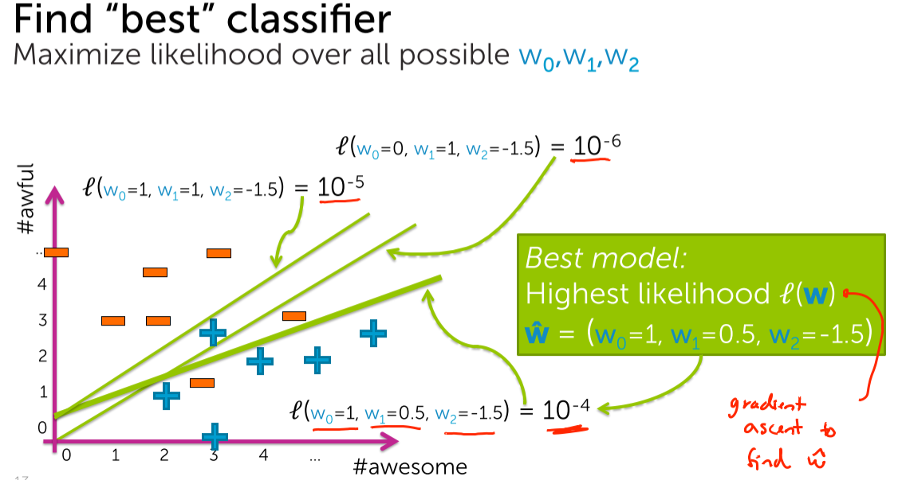

The question is, how to make the likelihood function   
to give a larger value 🡪 by fine tuning the coefficient.

The coefficient is fine tuned by gradient descent.

## **Data likelihood**

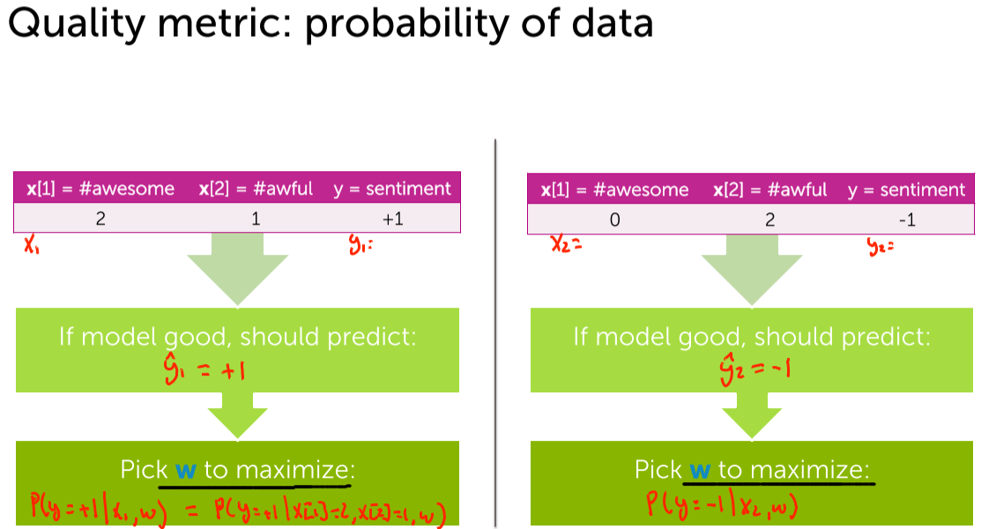



2 awesome’s and 1 awful 🡪 positive sentiment. [given]  
For this positive example we want the final probability to become as big as   
(i.e in positive direction y = +1) possible so that it will be close to the positive example as same as given.

0 awesome and 2 awful’s 🡪 negative sentiment. [given]

For this negative example we want the final probability to become as big as  
(i.e in negative direction close to y = -1) possible so that it will be close to the positive example as same as given.

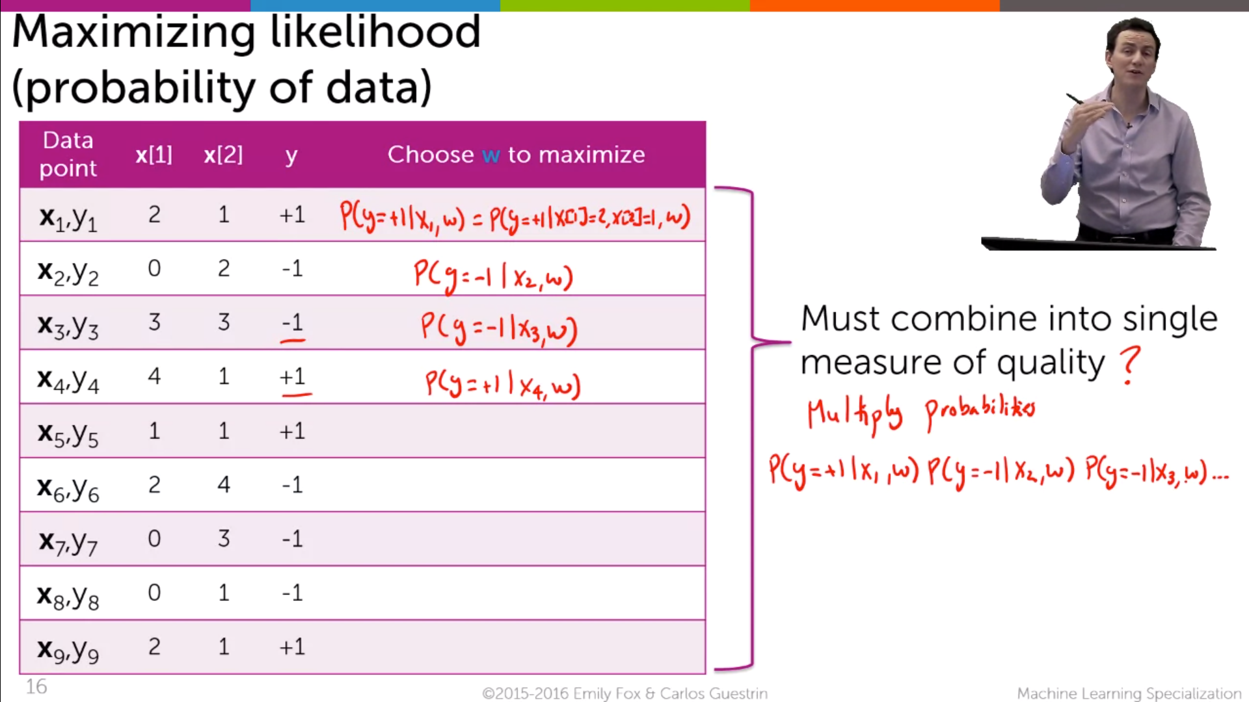

For +ve example we are trying to make the probability y=+1 🡪 maximise the probability towards P(y=+1)  
For -ve example we are trying to make the probability y=-1 🡪 maximise the probability towards P(y=-1)

How to combine these probabilities ?????

The reason you multiply is that you assume that every row is independent of each other.

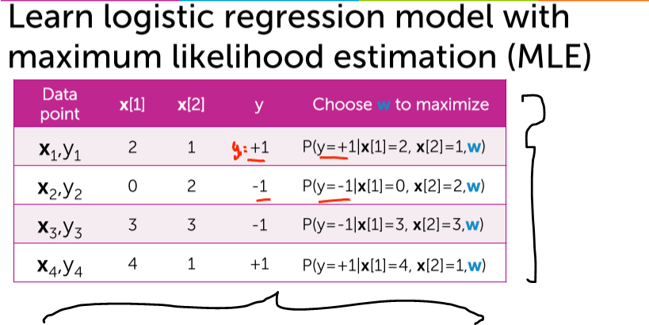

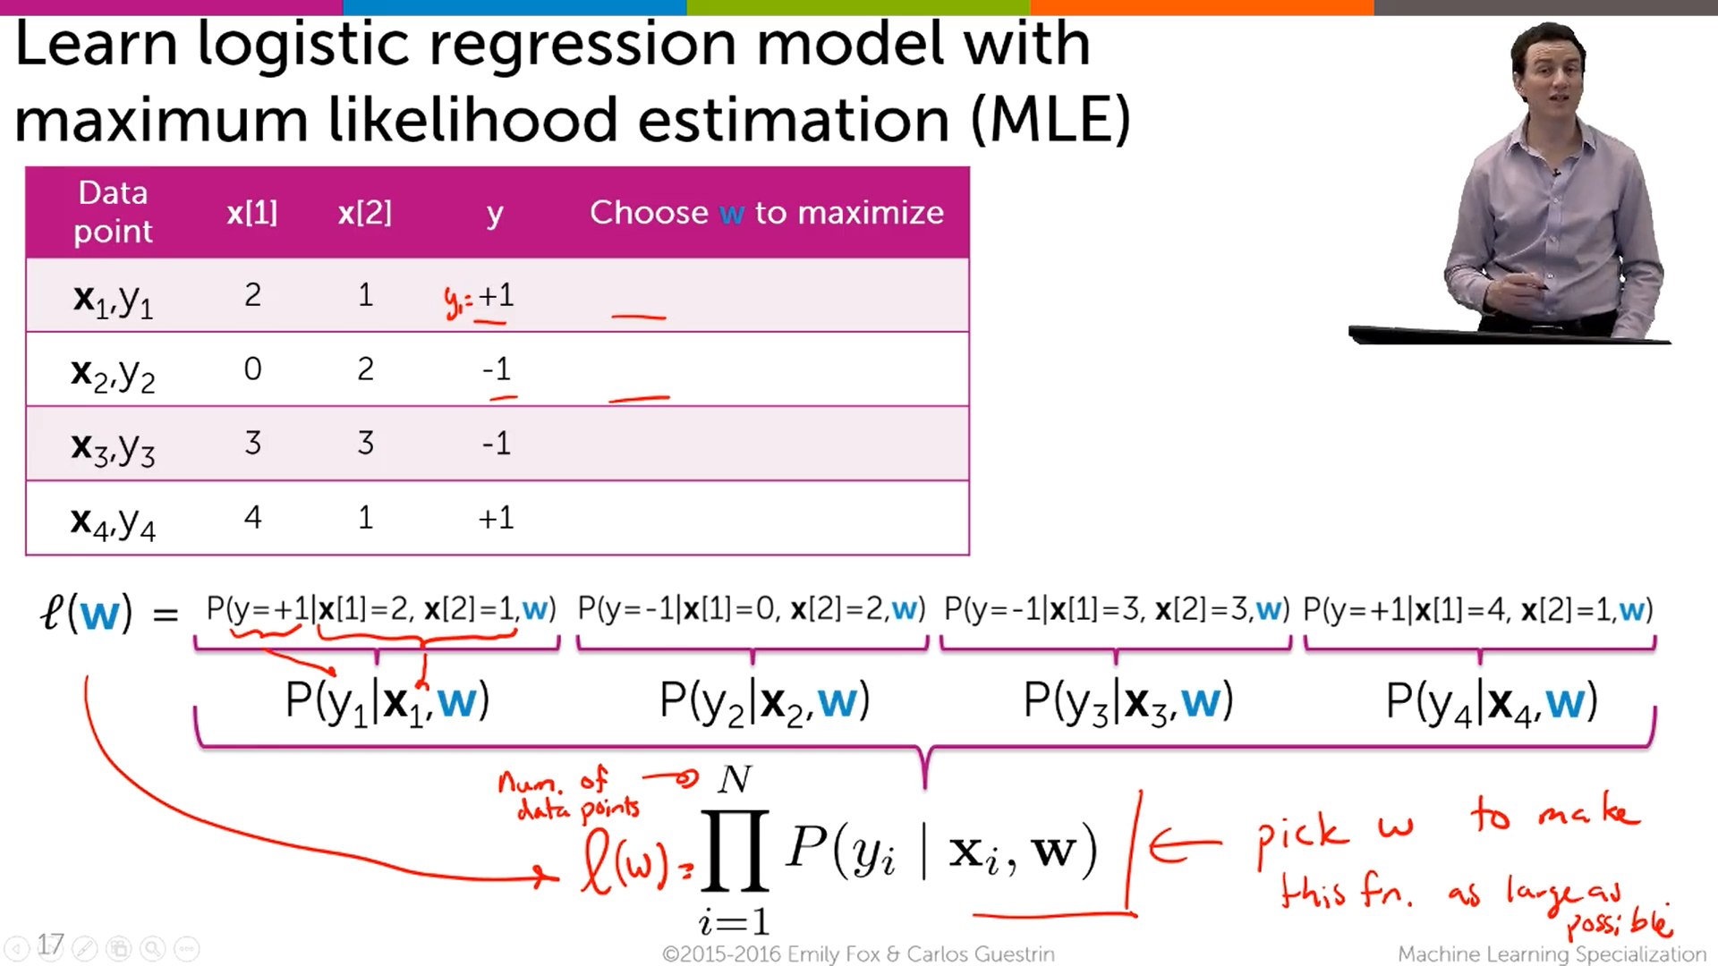

* Multiplying all the probability, likelihood function
* We want to pick a particular w for which the   
  likelihood function l(w) 🡪 maximum.
* This w is picked up by gradient Ascent algorithm.
* This is the likelihood function we are trying to optimize.

## **Finding best linear classifier with gradient ascent**

**Classification**

Quality Metric 🡪Data likelihood function (aim is to maximise)

ML Algorithm 🡪 Gradient Ascent algorithm (aim is to go to the top of the concave curve)

**Regression**

Quality Metric 🡪 Cost function (aim is to minimise)

ML Algorithm 🡪 Gradient Descent algorithm (aim is to go to the bottom of the convex curve)

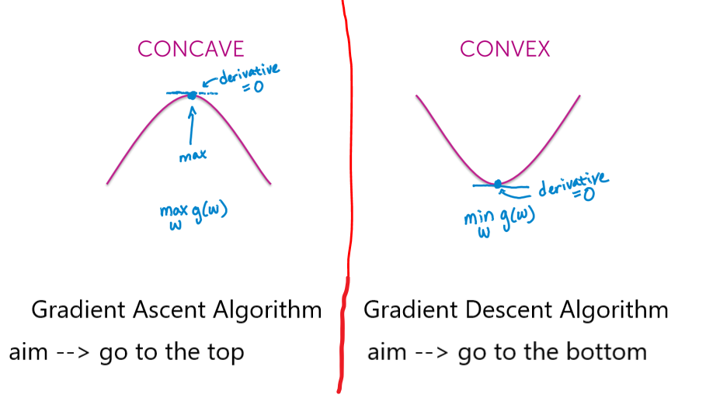

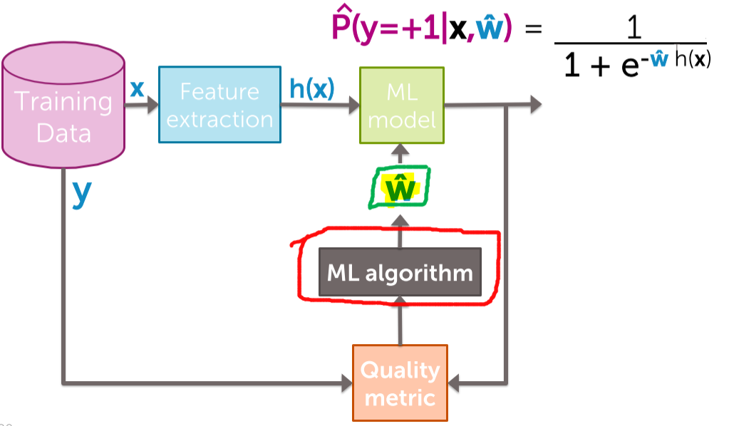

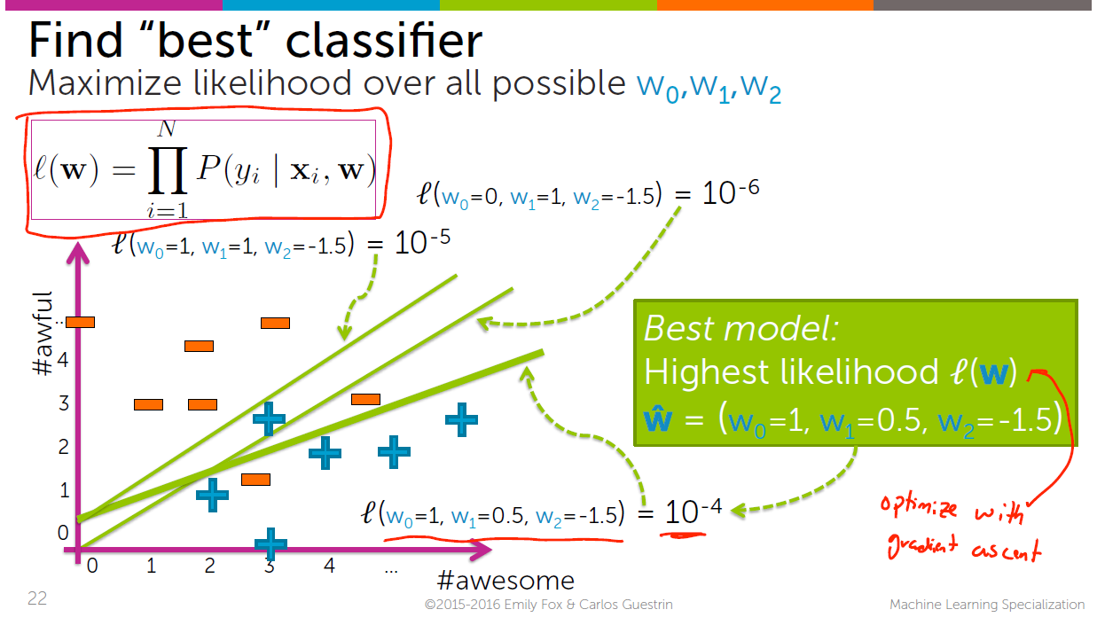

* Our aim is to find the w^ using gradient descent, and for which w^’s the likelihood function is maximum.
* As the output of the likelihood function closely approaches to 1, the more perfect our model will be.
* After that we have to find w^ which is done by Gradient Ascent .

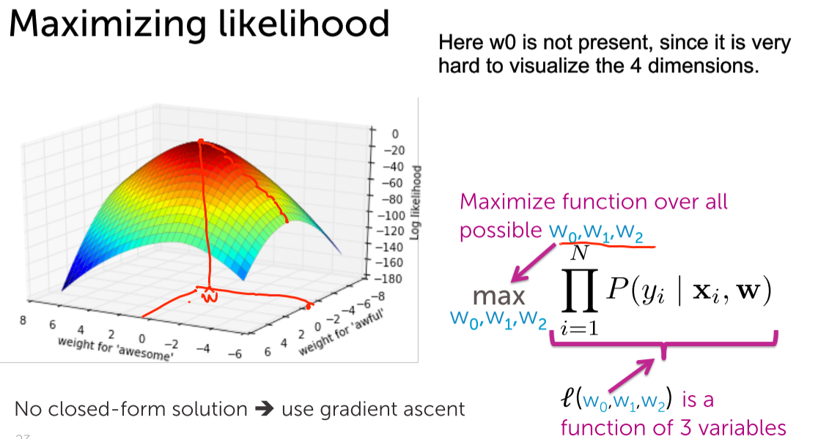

* Weight for awesome 🡪 0
* Weight for awful 🡪 -6
* With this if start to reach the top of the hill, the corresponding   
  Weight for awesome 🡪 0.5 and Weight for awful 🡪 -1
* We want to reach the to top of the hill, With that maximum height (w^), we can get the corresponding w’s for each and every feature.

# **Gradient Ascent Algorithm for learning logistic regression classifier**

## **Review of gradient ascent**

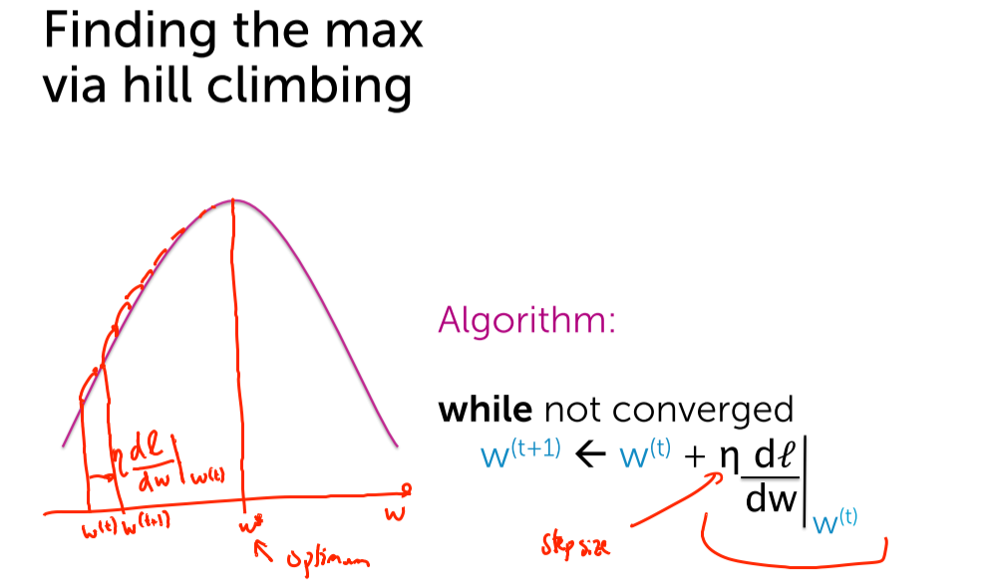

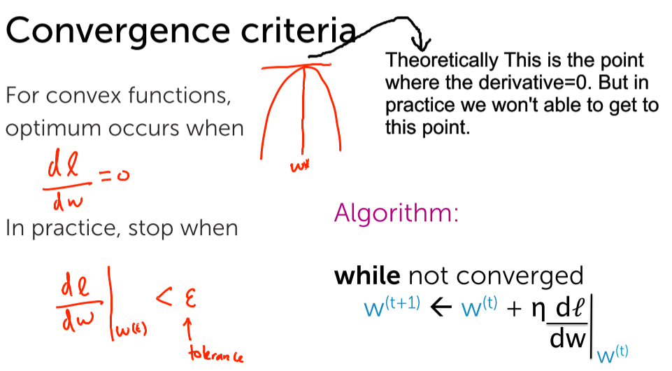

When the derivative(slope) = 0, then we can able to find the point at that maximum height. But we won’t get exactly. We are going to stop, when the derivative is smaller than the tolerance(epsilon). We will climb up and up until the derivative is sufficiently small. It is clear that we won’t able to approach exactly to the top but pretty closer to the top (i.e the w^).

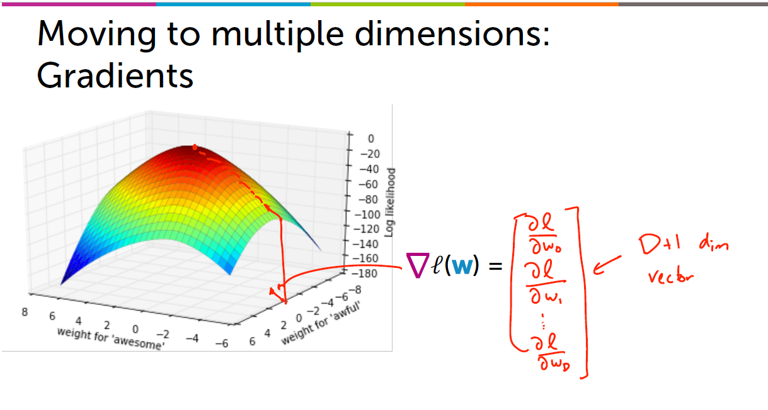

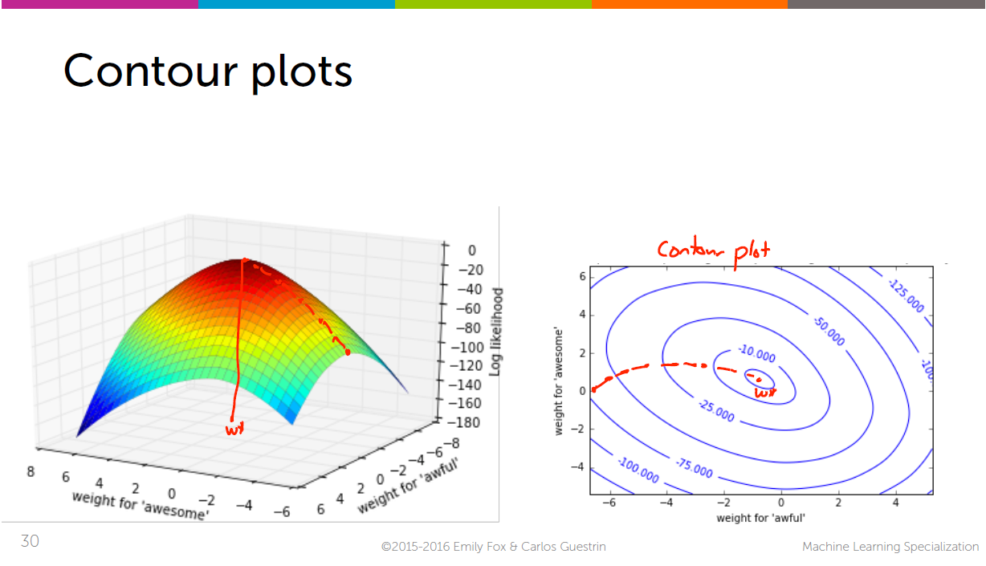



Both are same points

Visualizing the inner most part via contour plot.

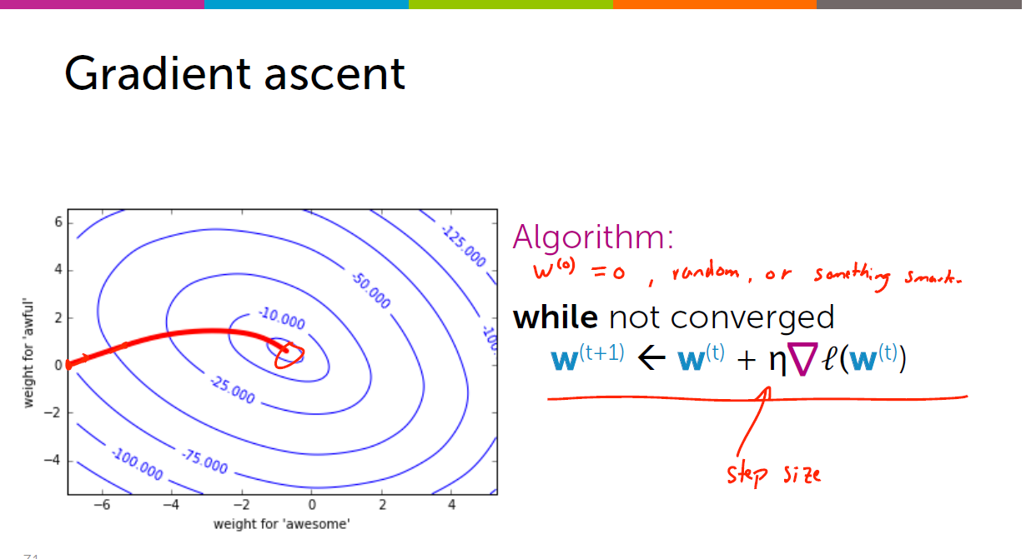

Remember the Positive sign (Since we have to climb the hill)

## **Learning Algorithm for Logistic Regression**

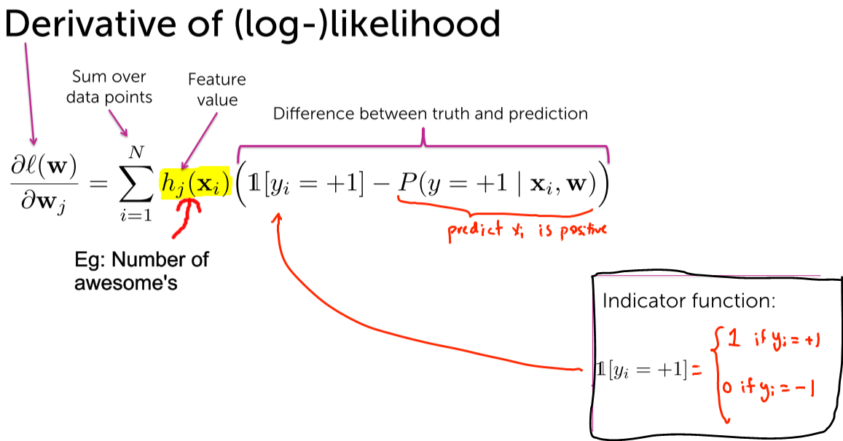

## **Example of computing derivative for logistic regression**

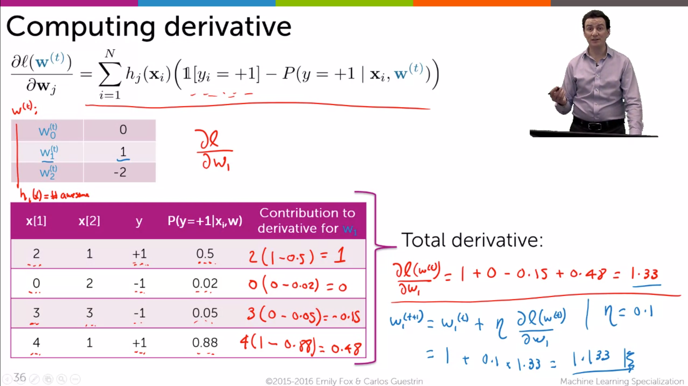

Here the weighs are 0,1,-2

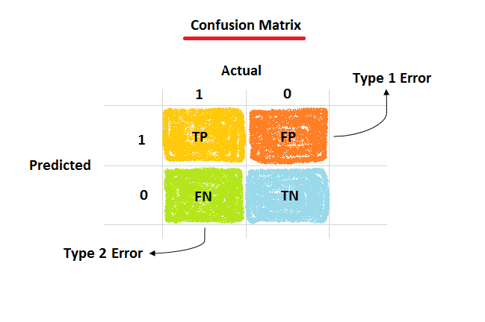

## **Interpreting the derivative for logistic regression**



1)derivative 🡪 (1-1) 🡪 0 (Observed=predicted)  
2)derivative 🡪 (1-0) 🡪 1  
3)derivative 🡪 (0-0) 🡪 0 (Observed=predicted)  
4)derivative 🡪 (0-1) 🡪 -1

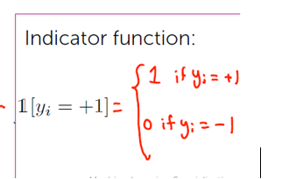

For -ve data-points, we get wrong, we decrease the coefficient to make the probability of it being positive smaller and thereby increasing the probability that , that data-point will be -ve.

So for the Positive probability   
🡪+ve training data-point, the coefficients are pushed to the top of the mountain  
🡪 for -ve training data-point, the coefficients are pulled down to the bottom.

## **Summary of Gradient Descent for logistic regression**

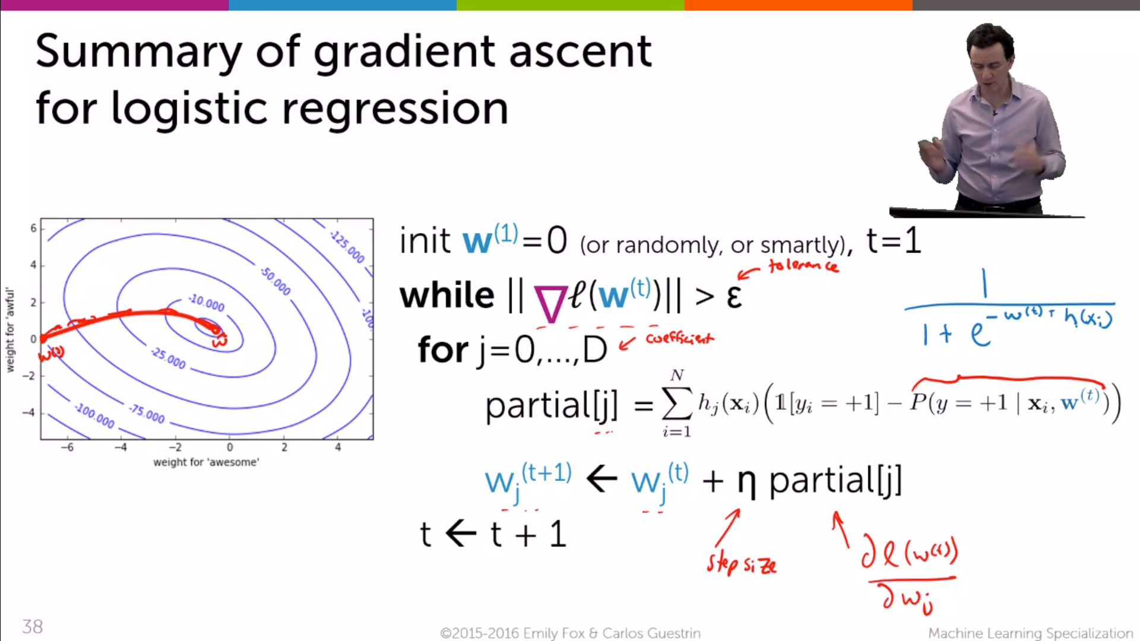

# **Choosing step size for gradient descent/ascent**

## **Choosing step size**

We should measure the quality metric [i.e log likelihood over all data-points] after each iteration.

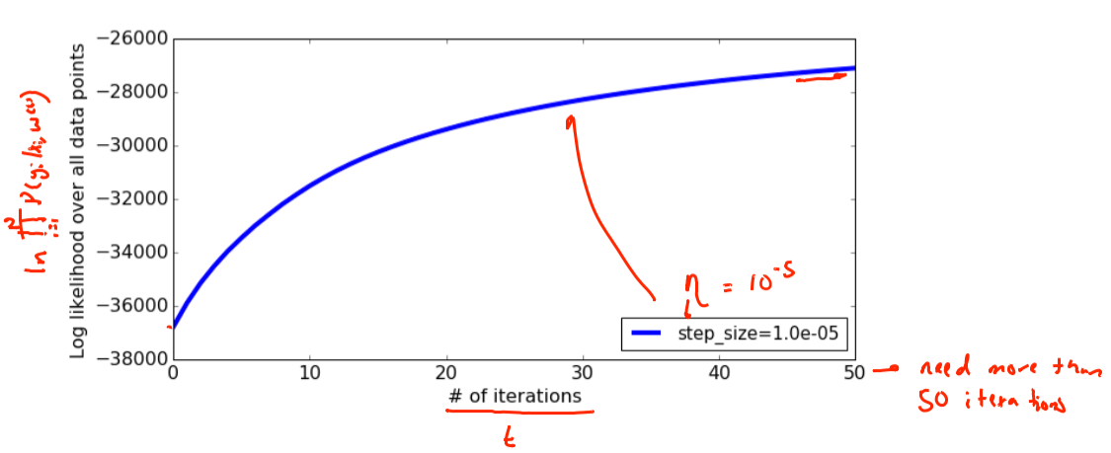  
Initially the curve is getting bigger and bigger in a pretty smooth way.  
The curve is still going to up after 50 iterations.   
So it require more iterations to flatten up.

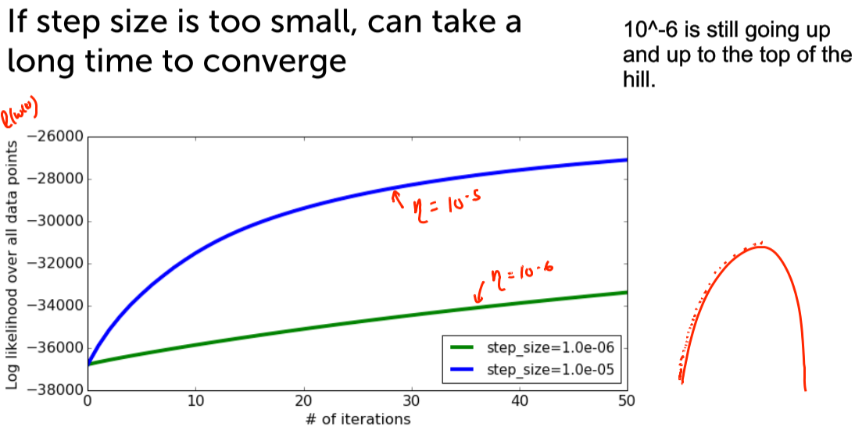

* 10^-5 > 10^-6 , so
* With 50 iterations 10^-5 reaches to -30,000 value.
* With the same 50 iterations 10^-5 reaches to -35,000 value.
* Over here 10^-5 is better.

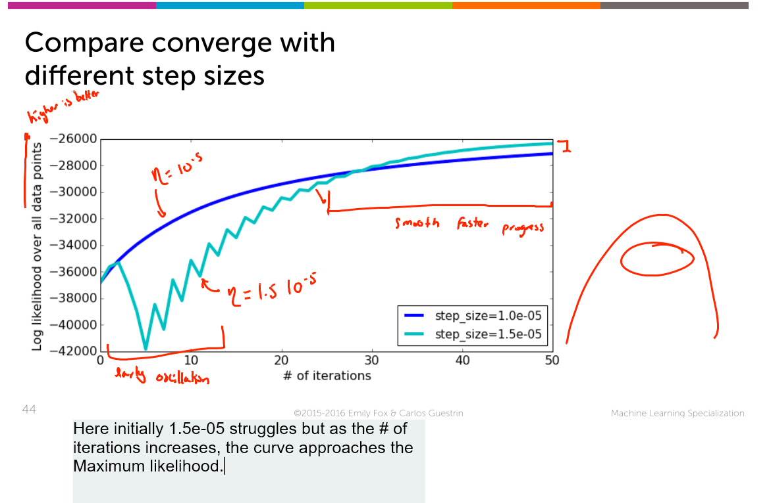  
Initially 1.5*10^-5 struggles but as the # of iterations increases the log likelihood function also increases.  
So it 1.5*10^-5 is better that 10^-5.

## **Careful with step sizes that are too large**

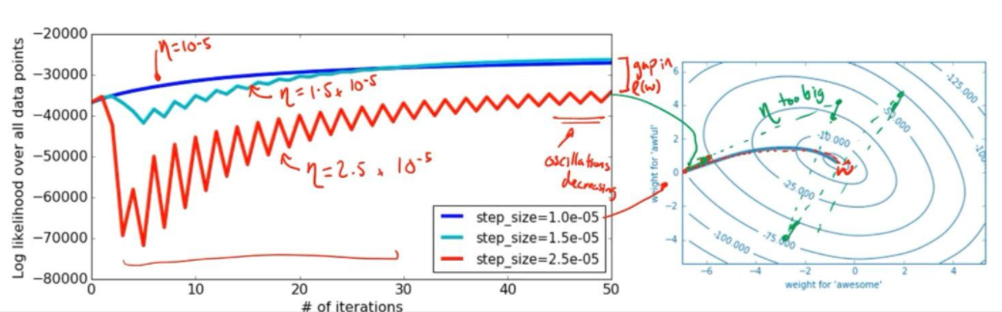2.5*10^-5 Red line 🡪 bigger oscillations in the beginning and the early oscillation phase goes on for a long time. The oscillation is not converging.

10^-5 🡪 blues curve is plotted in the counter plot and it goes straight to the centre.  
2.5 * 10^-5 🡪 green curve is plotted in the counter plot and it crosses the centre in a random manner and it can’t able to settle at the centre.

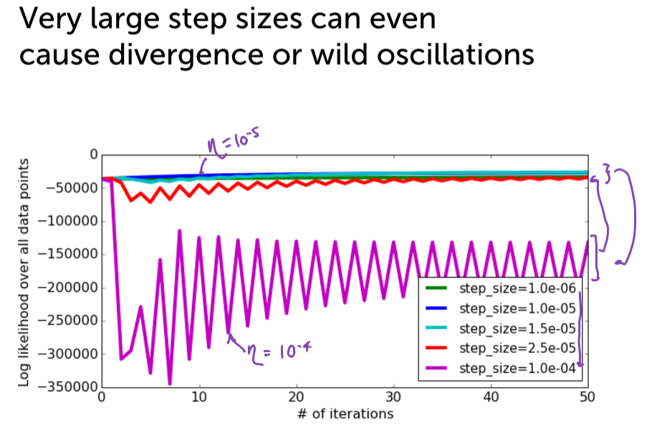

10^-4 is oscillating very long and the log likelihood function is not converging.

10^-6 🡪 too small and 10^-4 🡪 too big  
Now after experiments we got a range.

## **Rule of thumb for choosing step size**

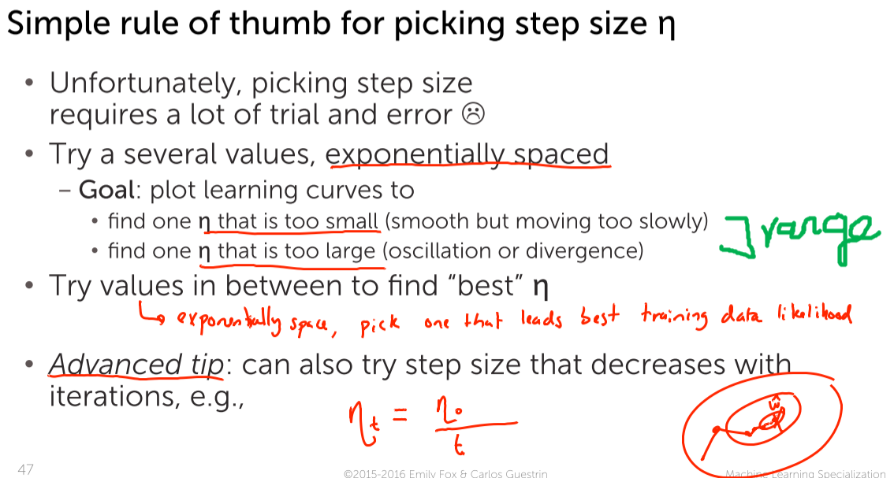

* It s good to pick up the step size that decreases over iteration.
* Though at the beginning it will take very large steps, since we are far away from the optimum. But towards the end it will take very small tiny steps to reach the exact optimum.

# **(ANG) Need for a Logistic regression cost function**

## **Cost function**

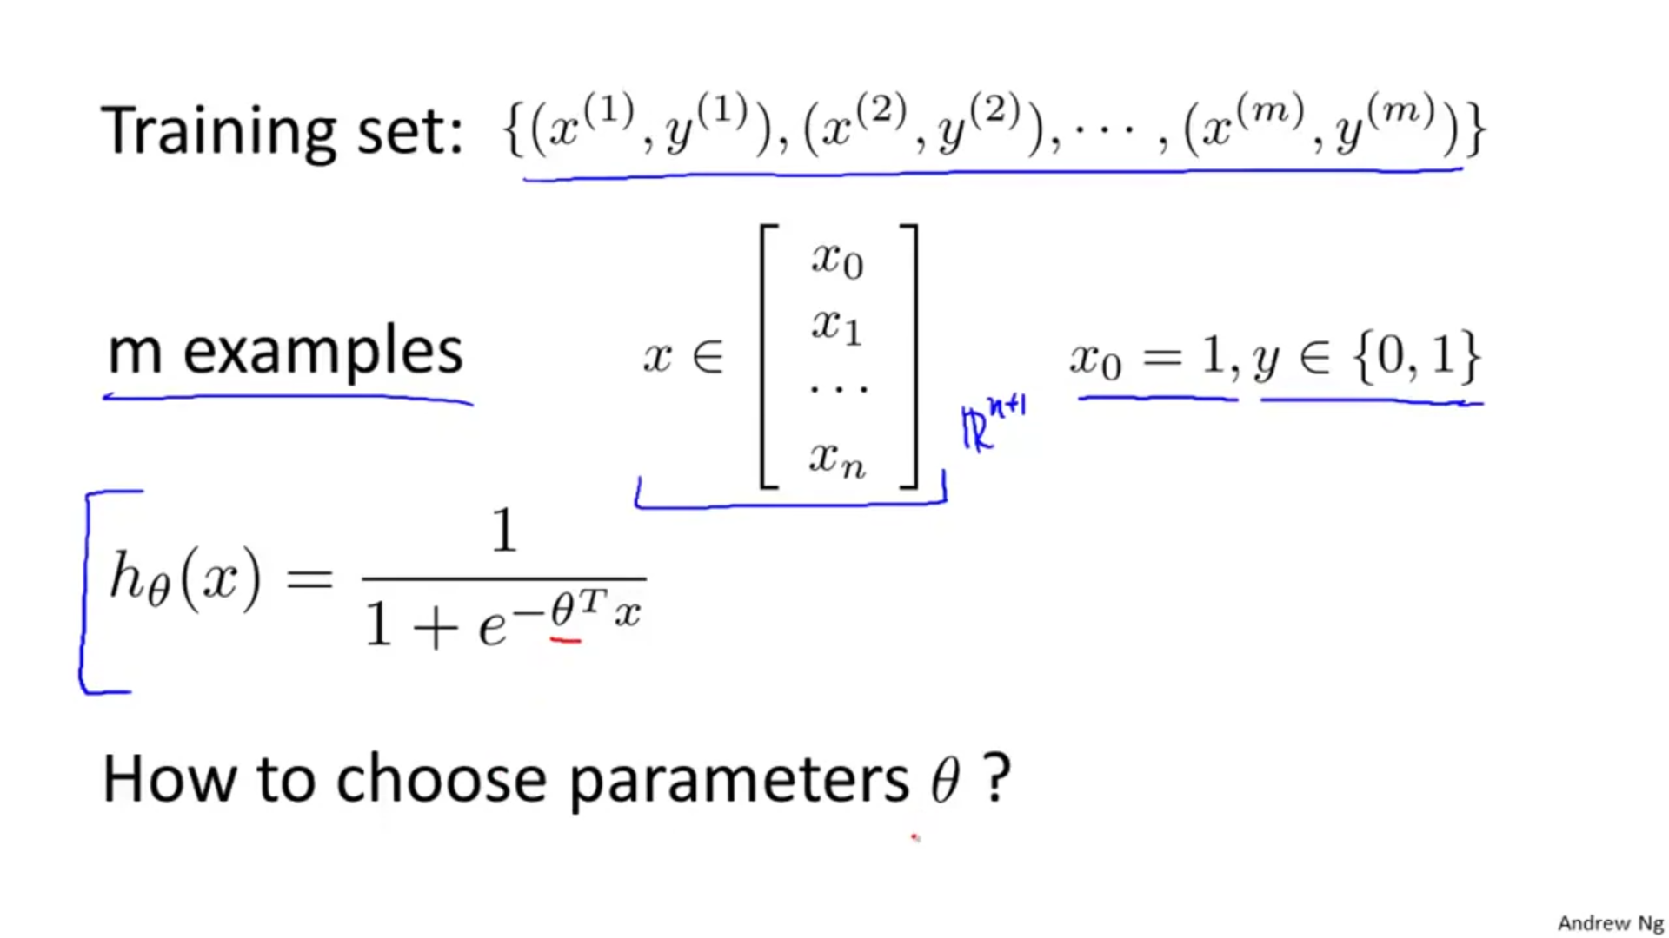Given the training set and with the hypothesis how are we going to choose the parameter theta ??

### **What happens if we use linear regression’s cost function for logistic regression also ????**

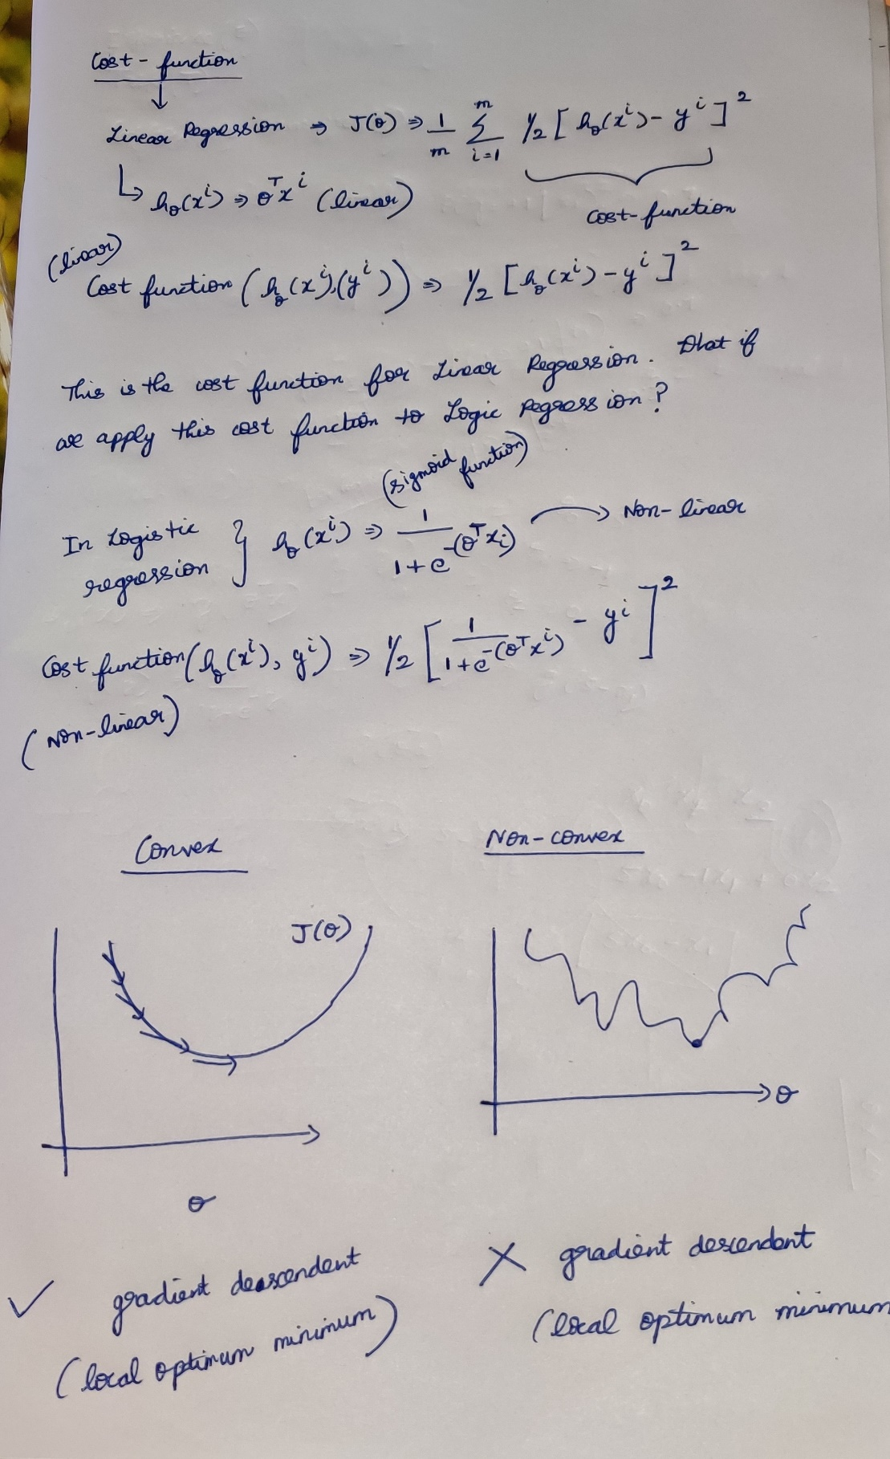

* If I run gradient descendent on a convex function, it is very clear that the algorithm will approach to the local minimum point.
* If I run gradient descendent on a non-convex function, there is no way to reach to approach to the local minimum point.
* So the cost function used for regression cannot be applied to the logistic regression.

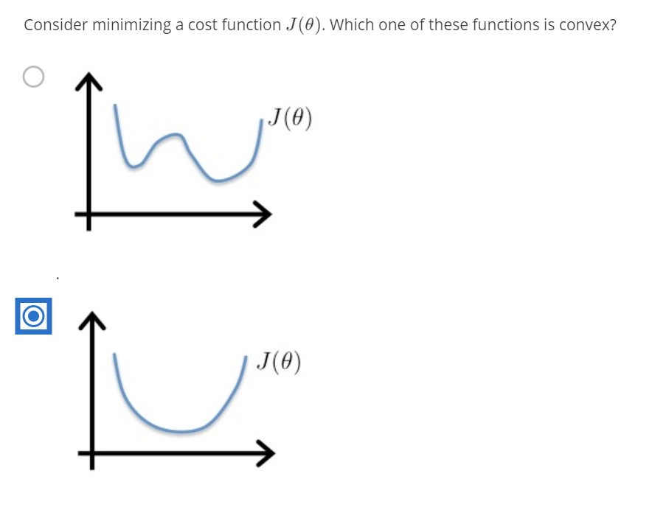

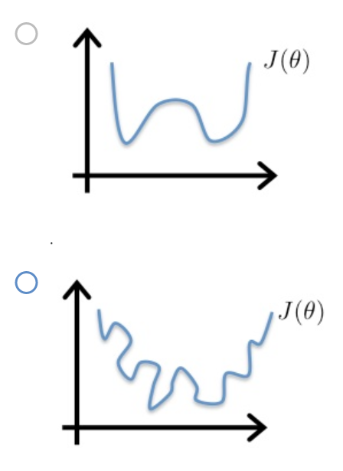

### **Logarithmic plots**

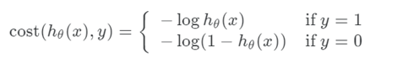

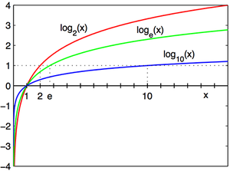

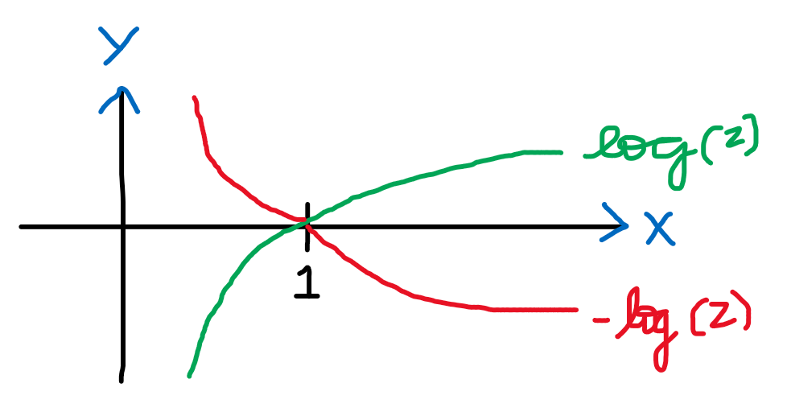  
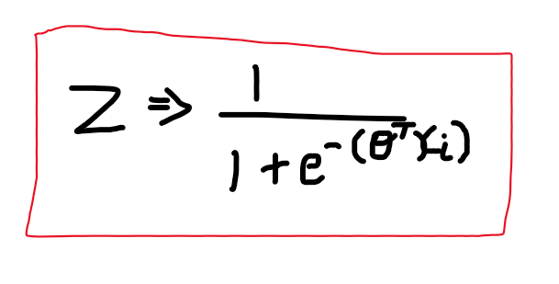

If y=+1

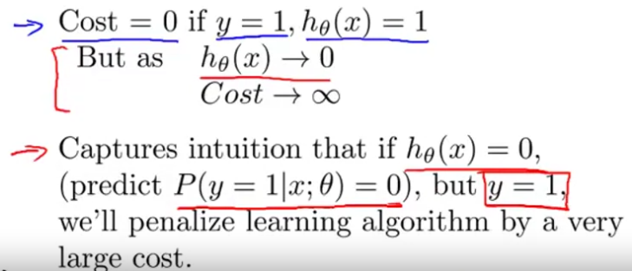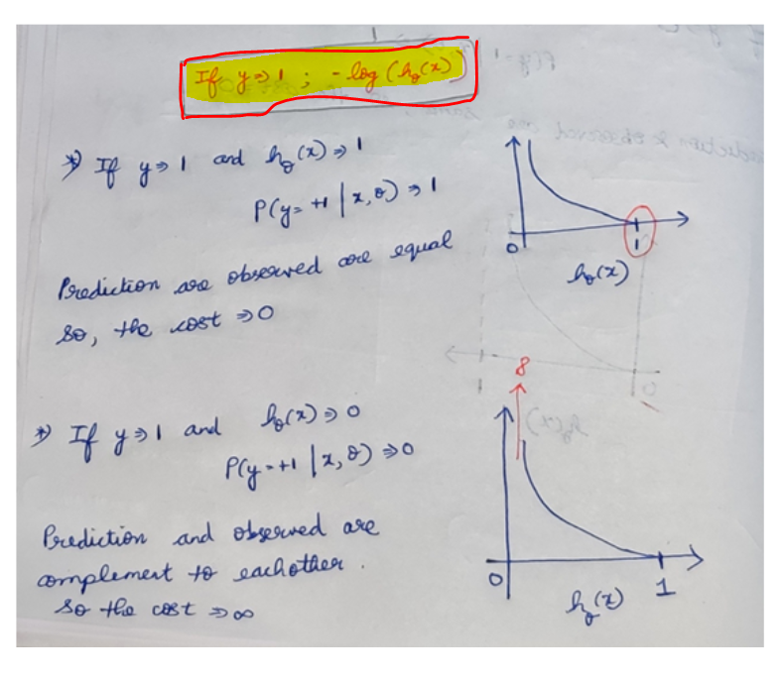

If y=0  
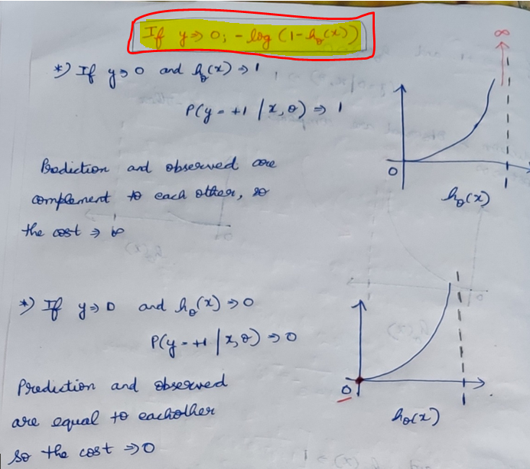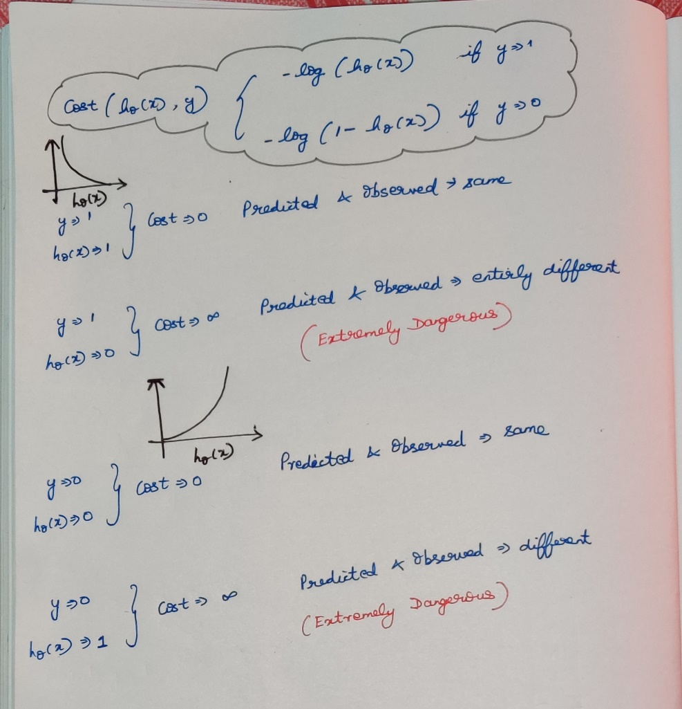

### **Quiz**

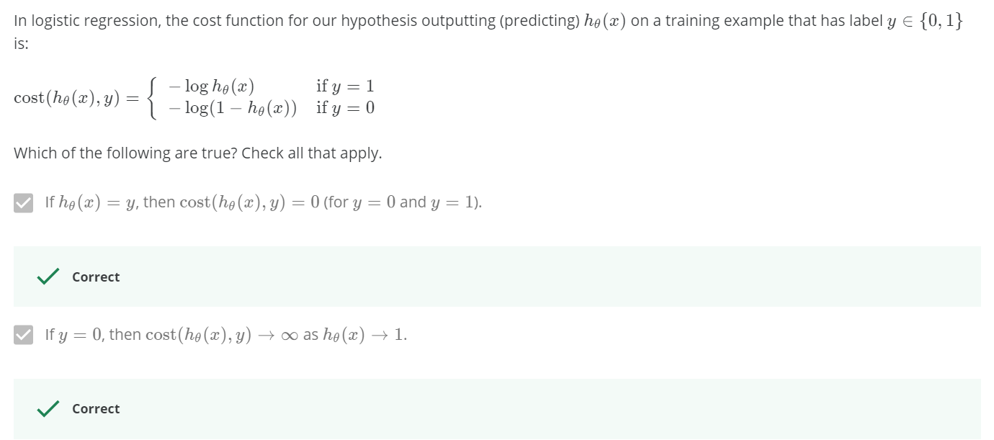  
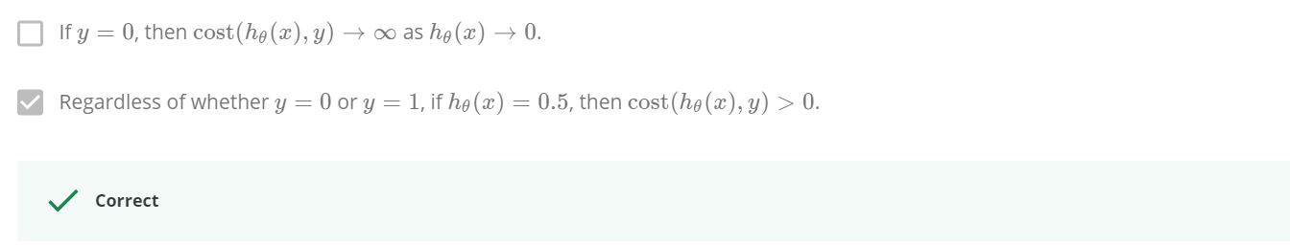

### **Reading**

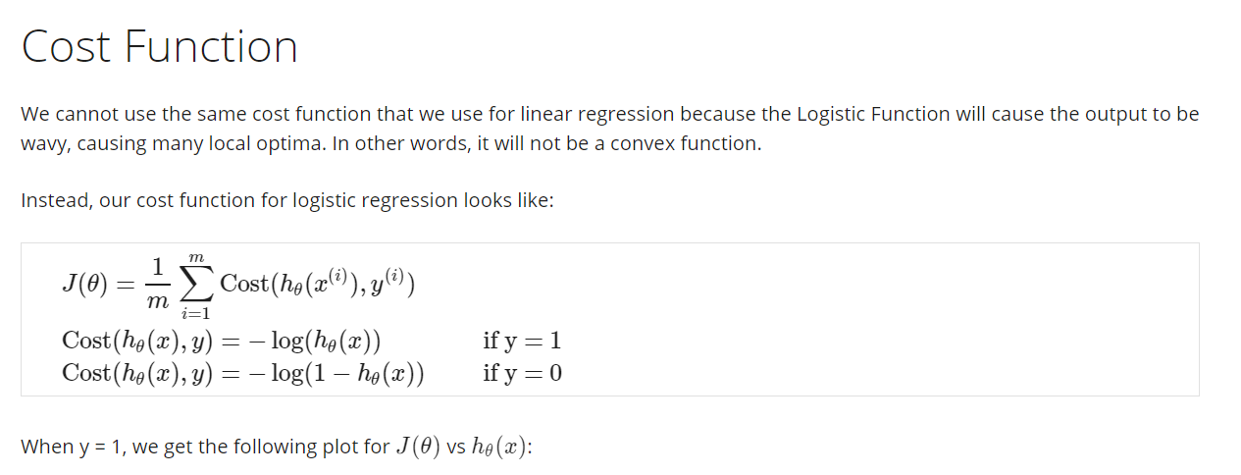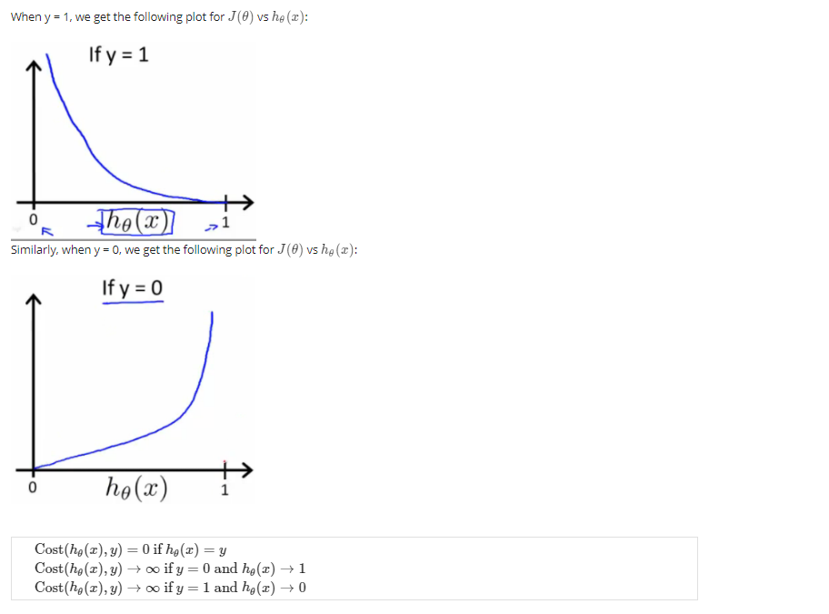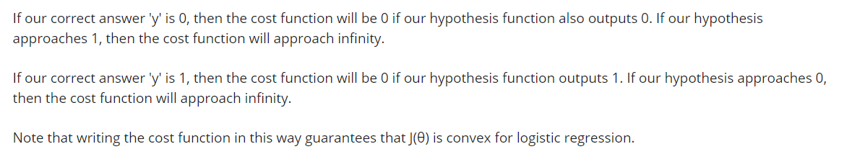

# **Deriving gradient of logistic regression**

## **Deriving gradient of logistic regression: Log trick**

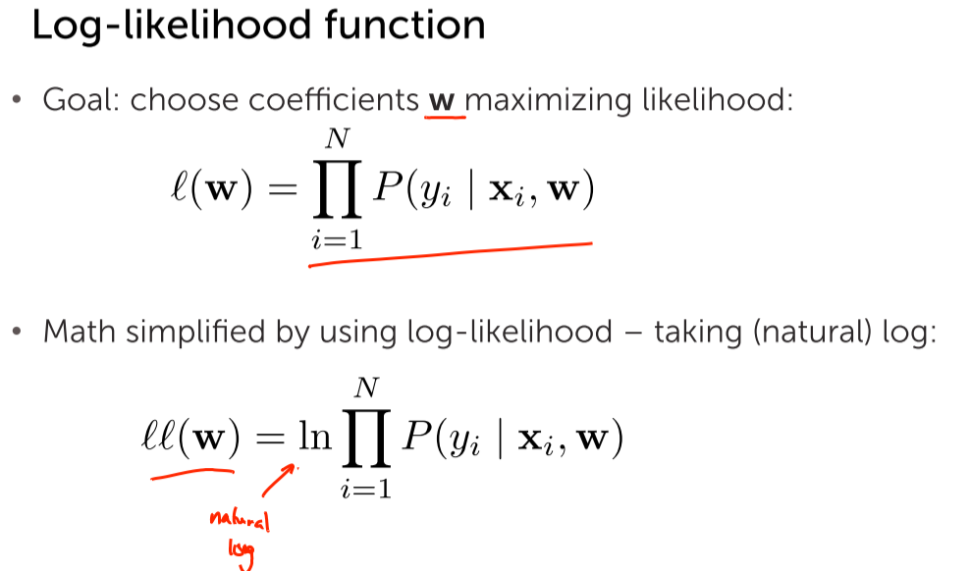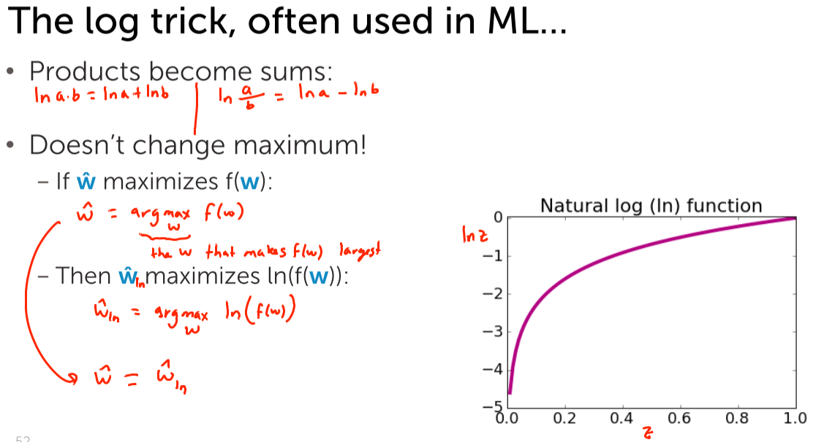

Introducing log doesn’t change anything

## **Expressing the log-likelihood**

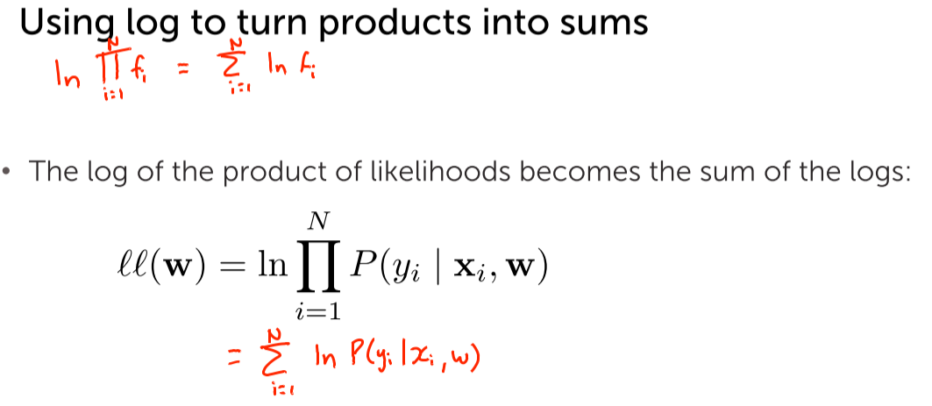  
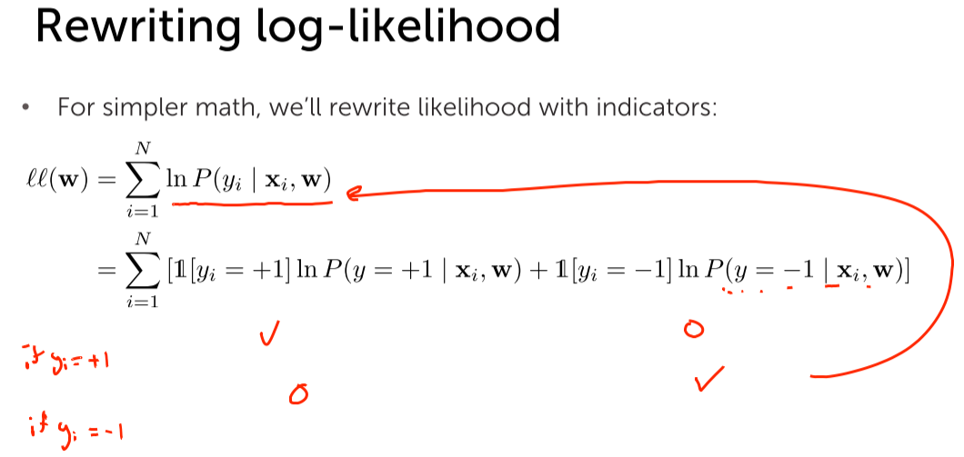

## **Deriving probability y=-1 given x**

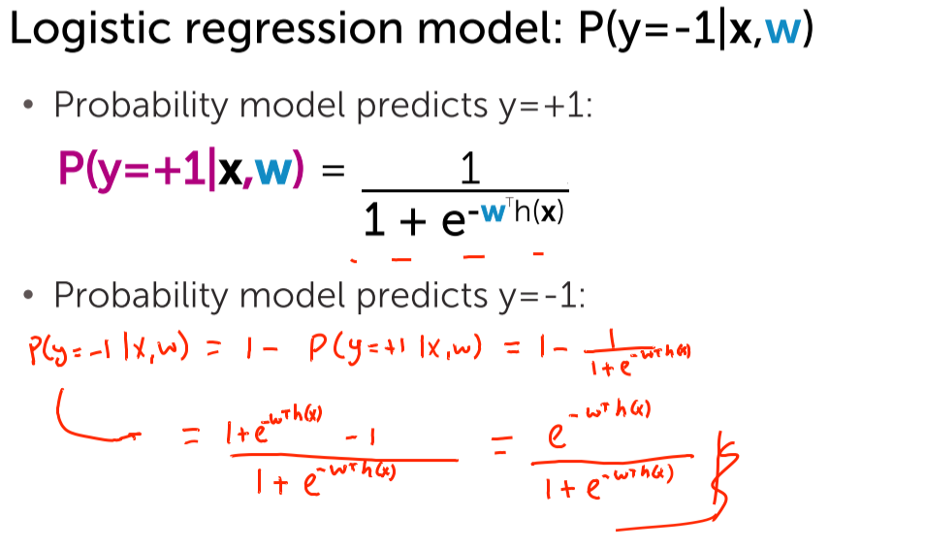

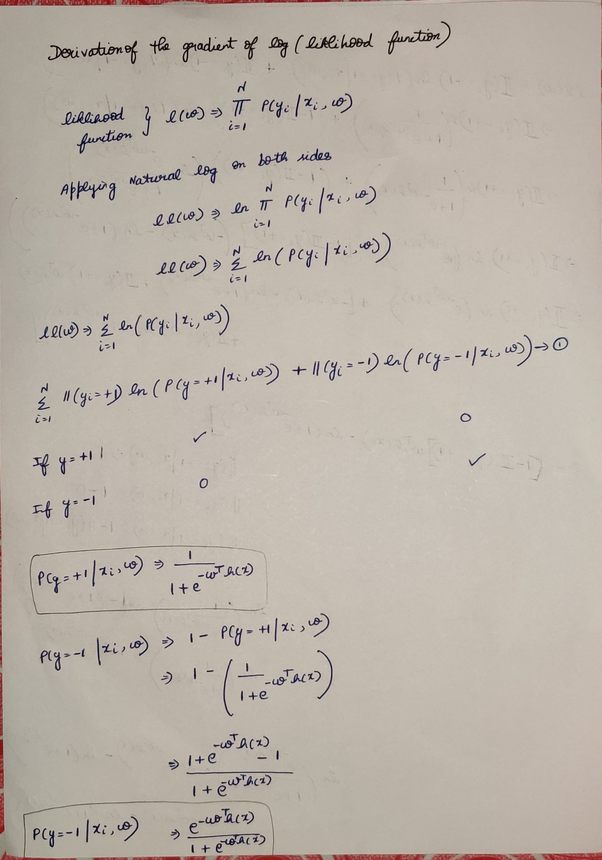

## **Rewriting the log likelihood into a simpler form**

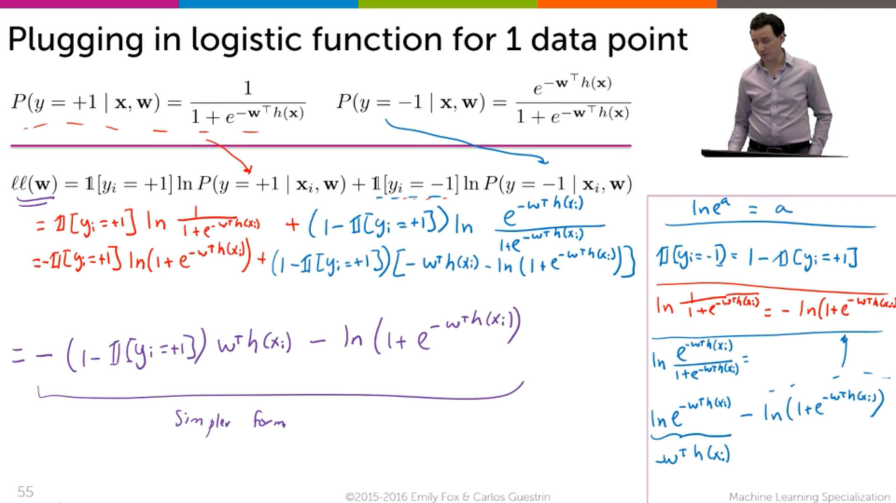

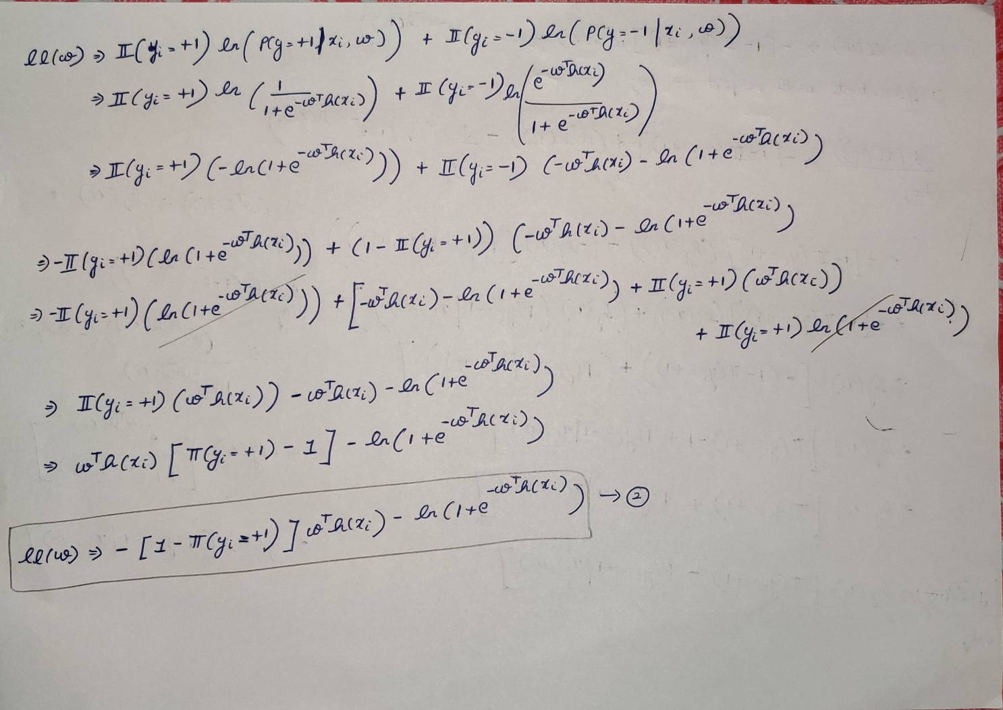

## **Deriving gradient of log likelihood**

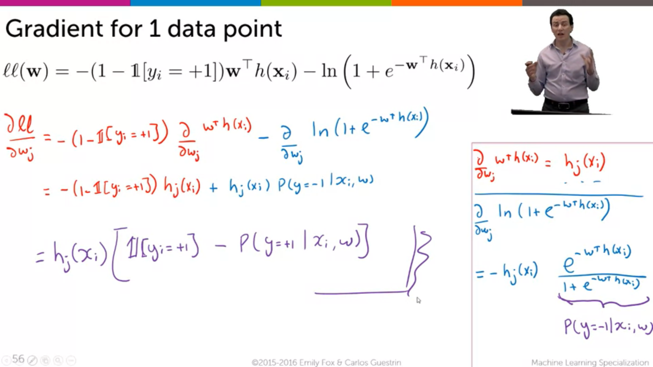

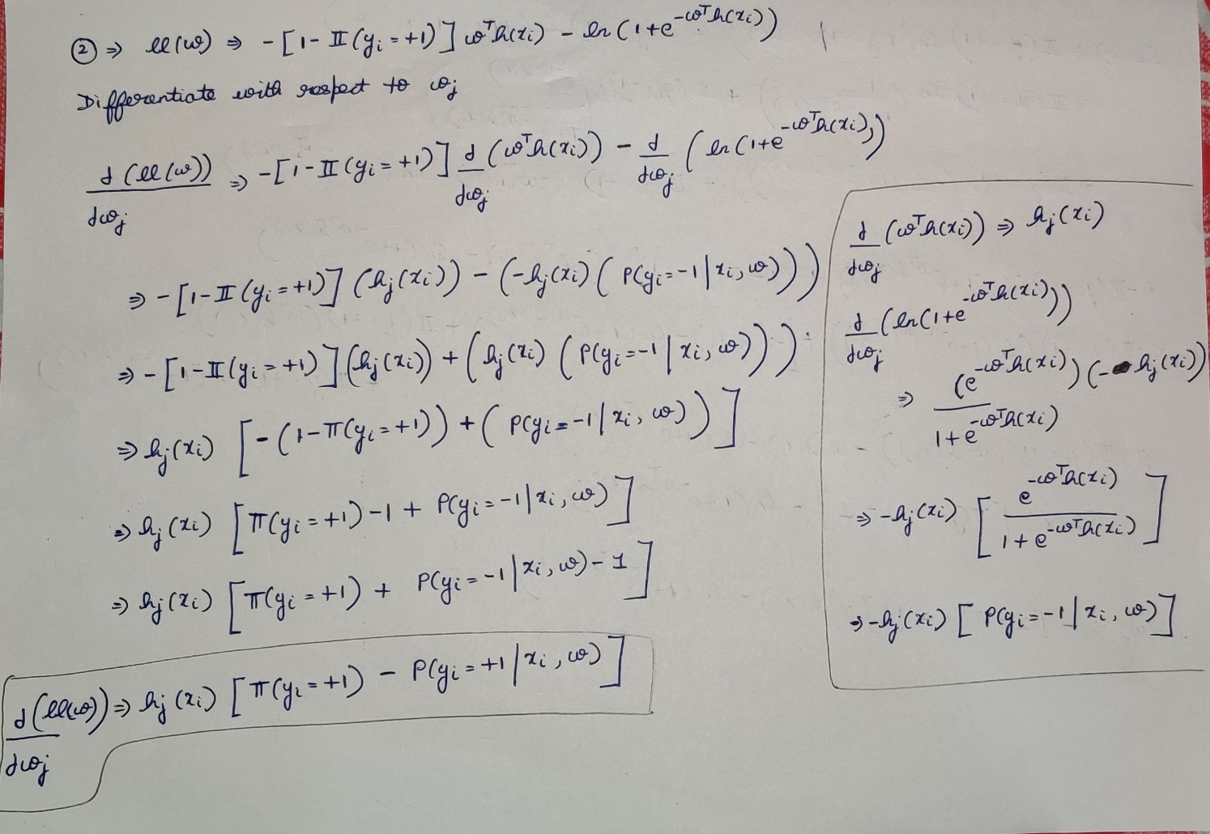

For the data’s having only one independent feature:

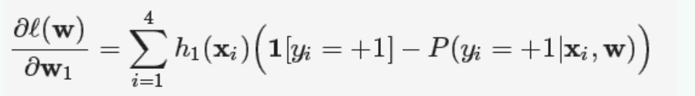



# **Summarizing learning Linear Classifier**

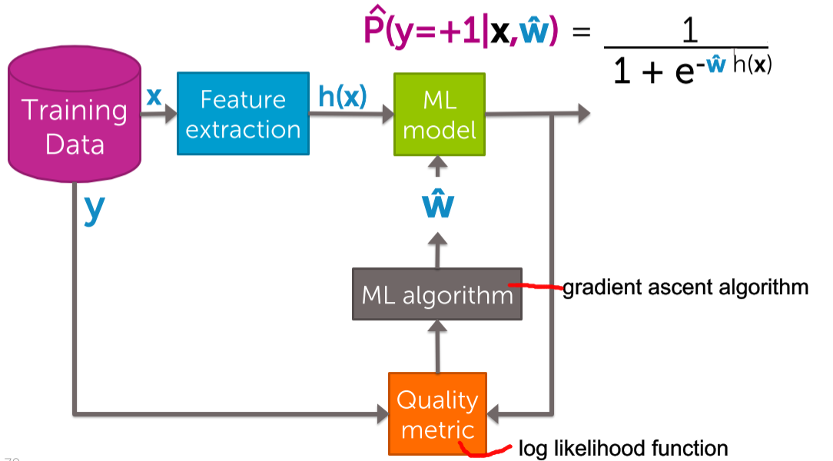

***2) Gradient Ascent Algorithm for learning Logistic Regression Classifier***

**i)Review of Gradient Ascent**

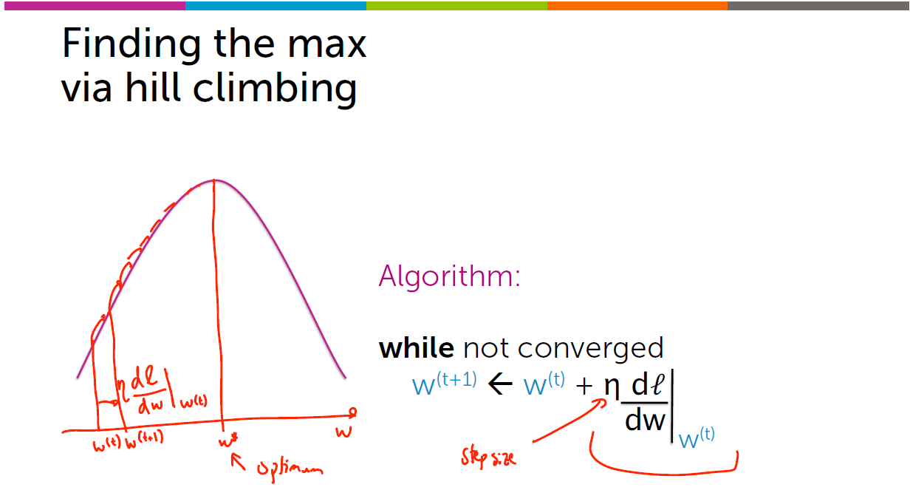

It is required to climb the hill to reach the top of the hill.

**ii) Actual Learning algorithm for logistic regression**

Both the truth and the prediction is for +ve example.

Features How much my model predicts that xi is +ve?????

Eg(# of awesomes)

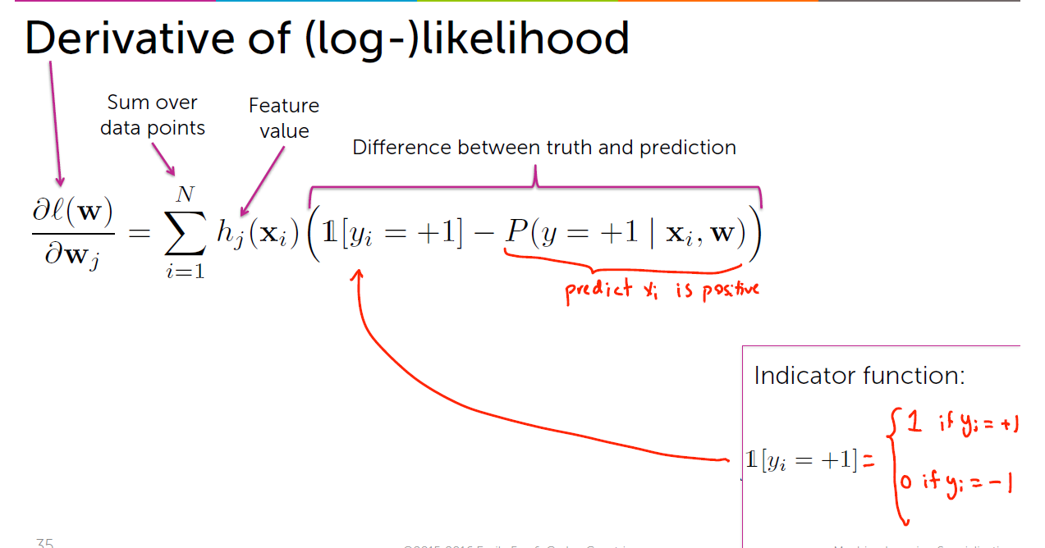



If the data-points has many-many awesome’ s (let 20) it has more contribution to the derivative. And the coefficients are multiplied by 20 awesome’s.

If the data-points has 0 awesome’ s then there is no contribution, because even if the coefficients are higher/lower [ 0*coefficient 🡪 0]

**Awesome feature**

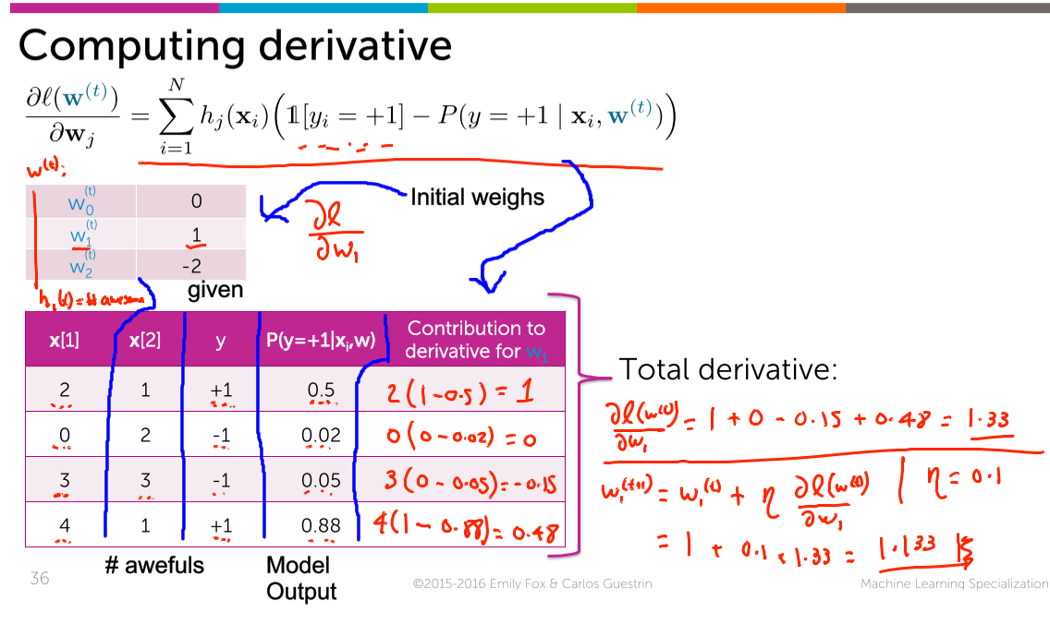

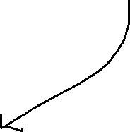

The predicted probability output is 0.02 (which is very-very close to 0). And the given value is also -1 🡪 Perfect Prediction.

**Is it possible to predict the derivative for x[2] (i.e awesome) ????**

We can’t predict for x[2](i.e awful) since the predicted P(y=+1 | xi,w) is given. But for awful we want P(y=-1| xi,w).

**v) Summary of Gradient Descent**

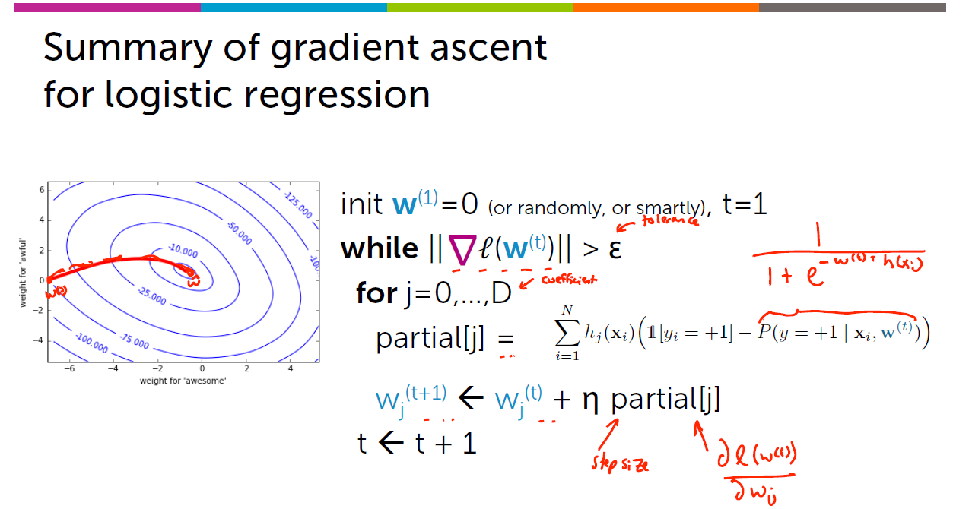

partial[j] 🡪 classification 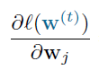 (Differentiating the likelihood junction with respect to w

partial[j] 🡪 regression 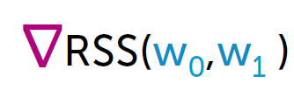 (Differentiating the Residual sum of squares with respect to w

**3) Choosing Step-size for Gradient Descent/Ascent**

**i) Choosing the step-size:**

**Aim 🡪 To attain larger values of likelihood function with lesser number of iterations.**

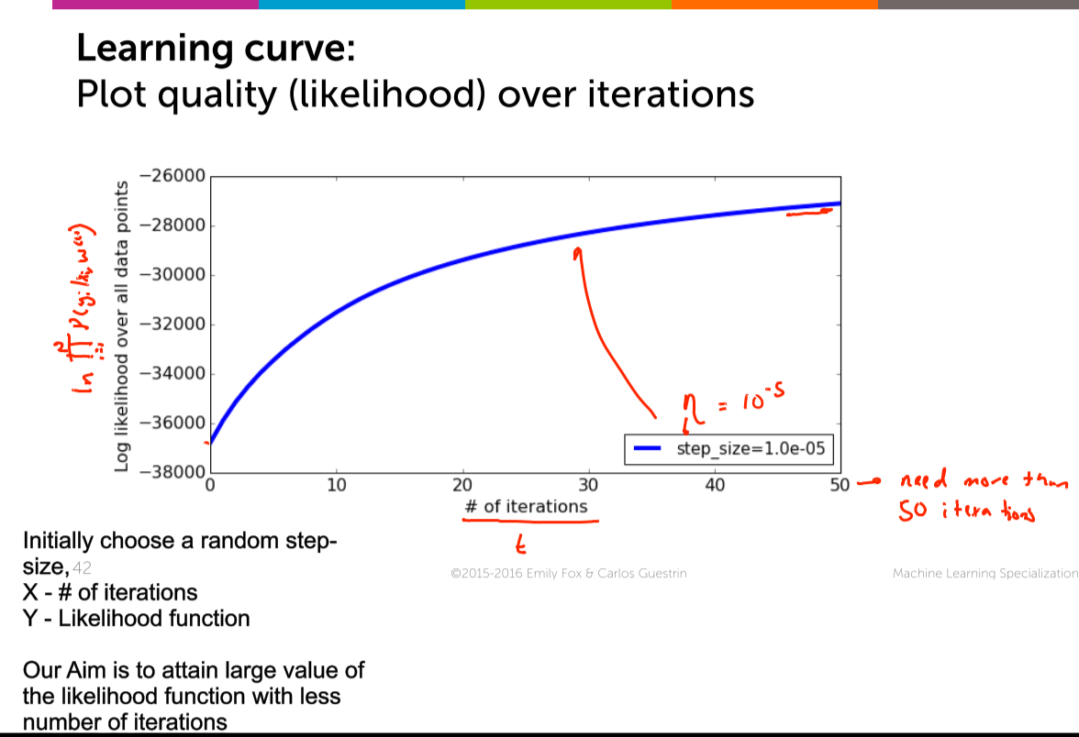

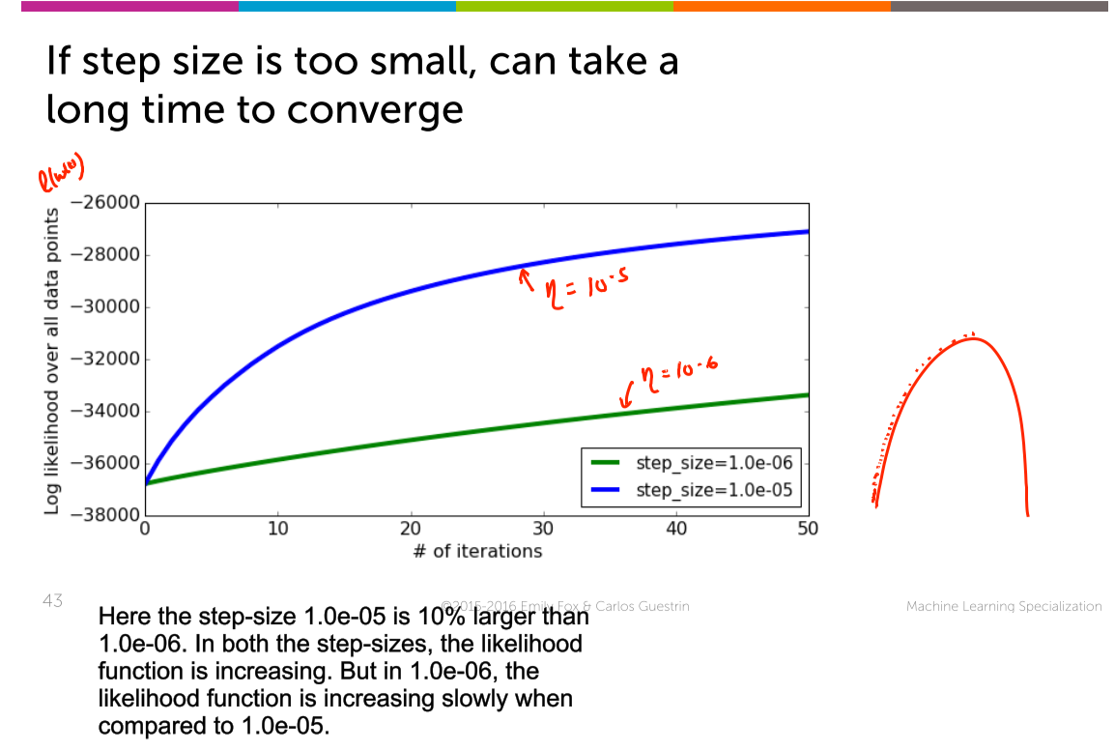

Smaller step-size 🡪 More time

Larger step-size 🡪 Less time

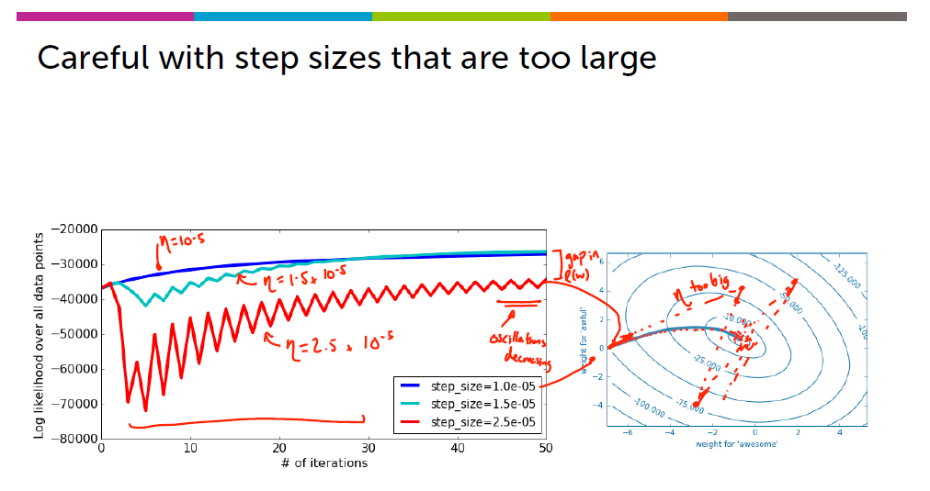

Here =2.5*10^-5 takes larger step-size, and goes back and forth continuously, and finally comes near to the top of the hill.



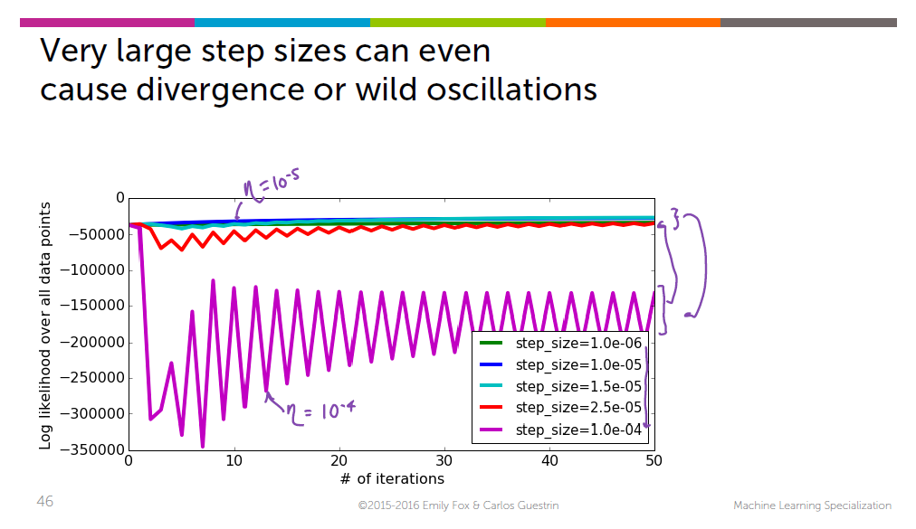

10^-4 🡪 also larger step size and takes many iterations to reach the top of the hill.

Now we learned that 10^-6 🡪 too small and 10^-4 🡪 too big, Now we are having a finite range to search for the step-size.

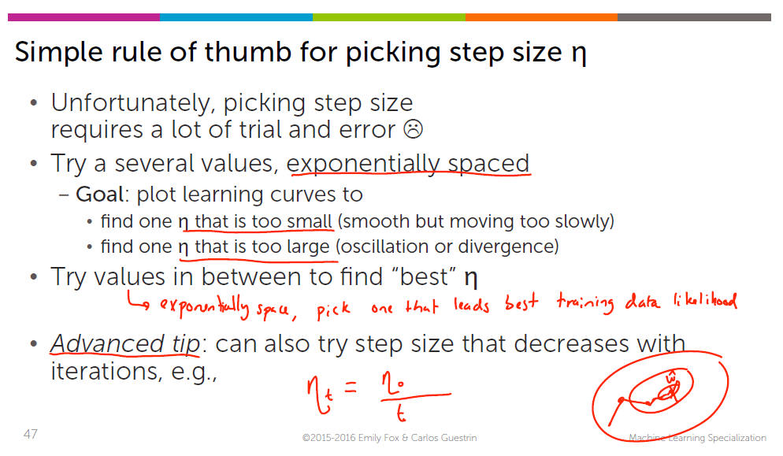

***4)Deriving the gradient of logistic regression :***

i) Deriving the gradient of logistic regression : log trick

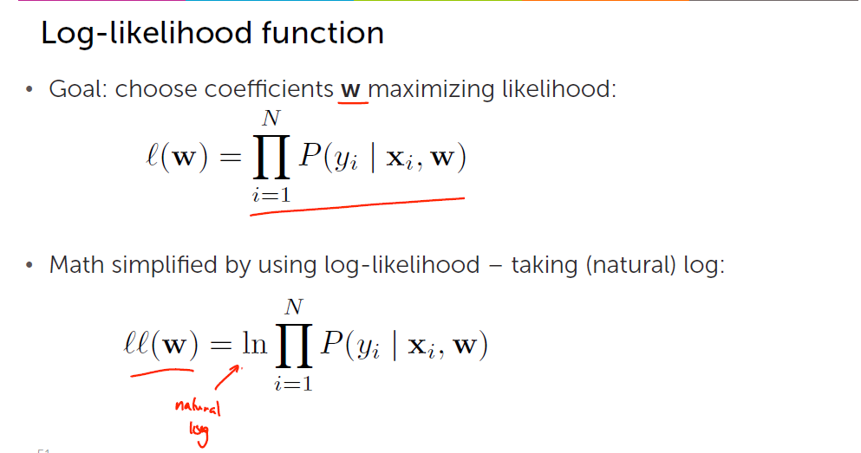

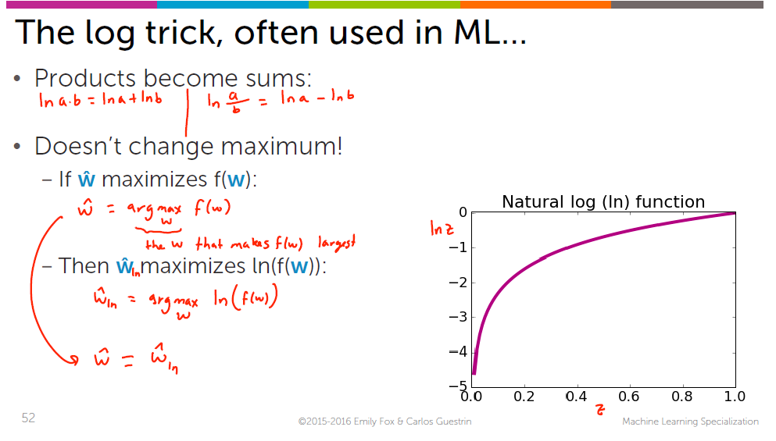

ii) Express the log likelihood function

log of the products = log of the sum

Before applying log, the derivative of the product 🡪 So complicated   
Now the derivative of the sum is just the sum of all the derivatives 🡪 Very easy

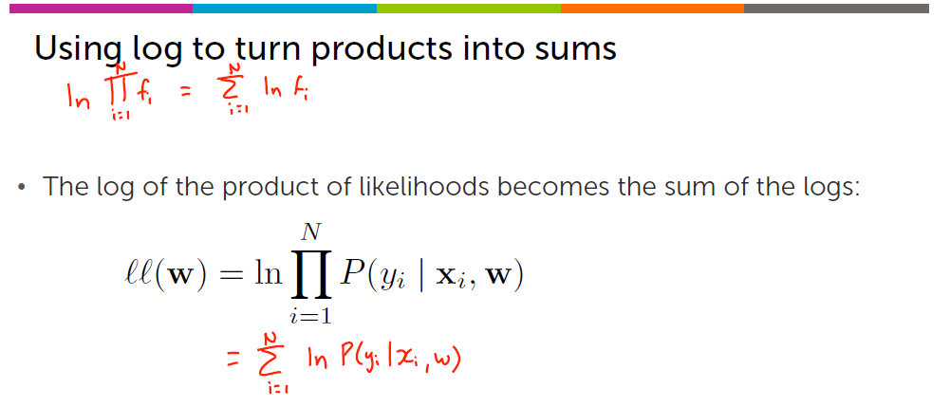

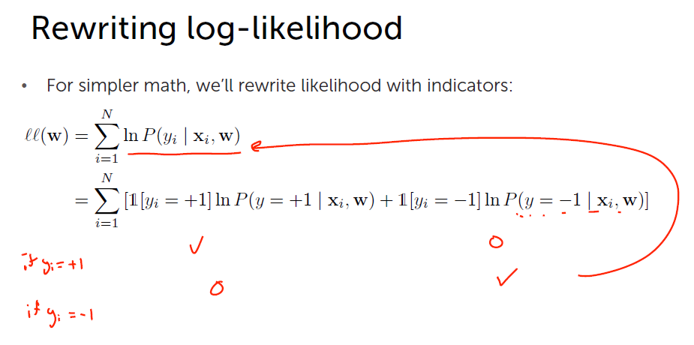



ii) Deriving the P(y=-1) |xi

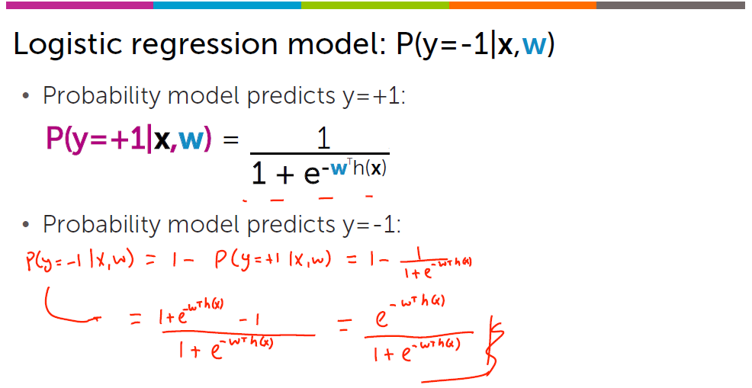



Reference :

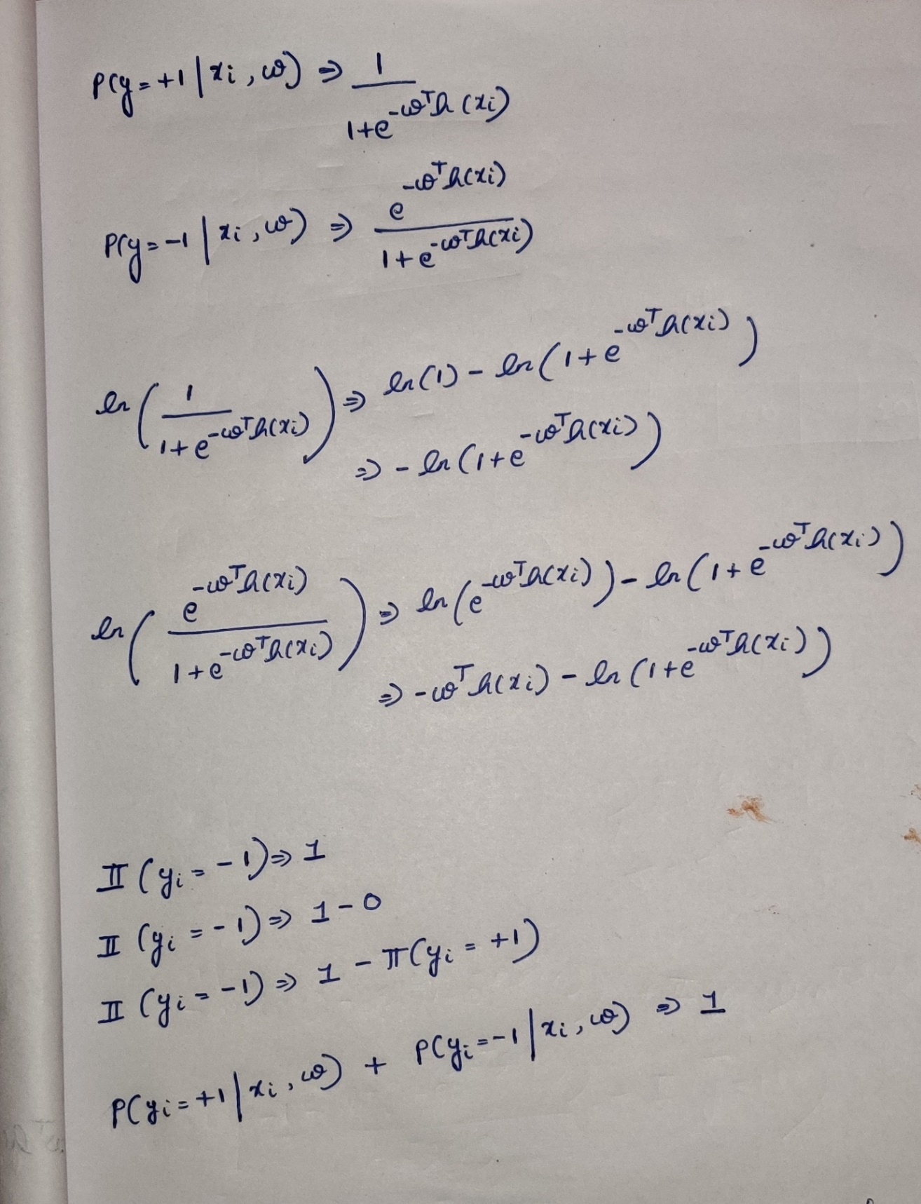

***6)Summarizing learning linear classifiers***

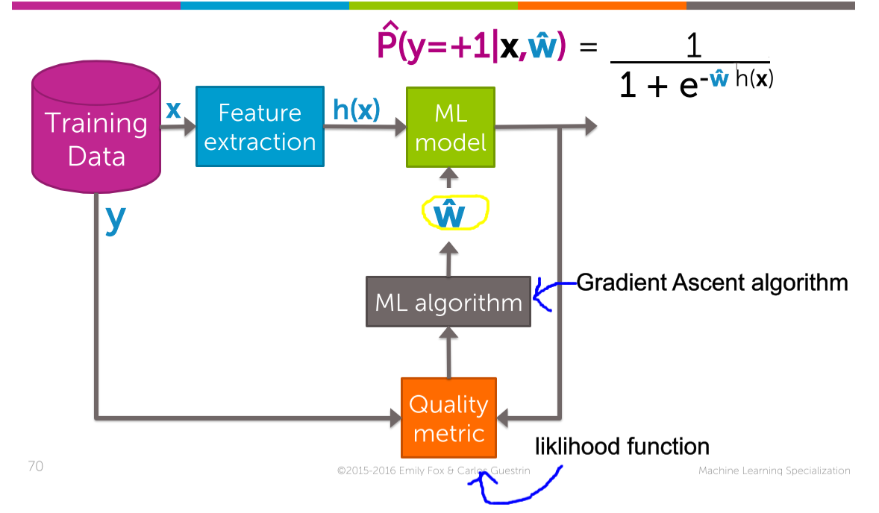



**Quiz questions :** 